

Dynamics 365 Nonprofit Accelerator

Admin Guide

**Published**: December 2020

**Accelerator Release Version**: v3.0

Table of Contents

Nomenclature Update 4

Table Matrix 4

Import solution to Dynamics 365 8

Import Solutions Using the Package Deployer 12

Download the Package Deployer 12

Solution Options 13

Package Deployment 13

SDG Sync Process 18

Configure SDG Sync Process (solution-based) 18

Execute SDG Sync Process (solution-based) 24

Program Design Canvas App 26

Import Program Design Canvas App 26

Enable Browser Zoom 28

Add SDG Icon Images 29

Configure Document Creation Process 32

Branding the Program Design App 34

Program Design App Mapping 36

IATI Codelist Sync 38

Configure IATI Codelist Sync Process (solution-based) 38

Execute IATI Codelist Sync Process (solution-based) 44

Install & Configure IATI Codelist Sync Process (standalone flow) 46

Execute IATI Codelist Sync Process (standalone) 56

Nonprofit and Dynamics 365 for Finance Integration Overview 59

Solution requirements 59

Setting up Dynamics 365 and Dynamics 365 Finance 60

Power Apps data integrations 61

Creating Power Apps connectors 62

Creating Power Apps data integration connection sets 64

Creating Power Apps data integration projects 66

Importing Power Apps data integration templates 68

Saving Power Apps projects as templates 69

Exporting Power Apps data integration templates 70

Creating Power Apps data integration tasks 71

Mapping Power Apps data integration fields 74

Using Power Apps data integration advanced query 75

Executing Power Apps data integrations 78

Scheduling Power Apps data integrations 78

Troubleshooting Power Apps data integrations 79

Using Dynamics 365 Finance data management 82

Data Mappings 87

Constituent 87

Donations 88

Program Delivery 89

Grants & Awards 89

References 89

# Nomenclature Update

Please note that the follow names have been updated and changed ([More Information](https://docs.microsoft.com/en-us/powerapps/maker/common-data-service/data-platform-intro#terminology-updates)):

|  |  |
| --- | --- |
| **Legacy term** | **Current term** |
| Entity, entities | Table, tables |
| Field, fields, Attribute, attributes | Column, columns |
| Record, records | Row, rows |
| Option set, multi select option sets  Picklist, picklists | Choice, choices |
| Two Options | Yes/No |

# Table Matrix

|  |  |  |
| --- | --- | --- |
|  | ✔ | New to v3.0.3.0 release |
| **Table** | **Nonprofit Core** | **Nonprofit IATI** |
| Account | ✔ | ✔ |
| Address | ✔ |  |
| Aid Type |  | ✔ |
| Assessment | ✔ |  |
| Availability | ✔ |  |
| Award | ✔ | ✔ |
| Award Version | ✔ |  |
| Benefit Recipient | ✔ |  |
| Budget | ✔ | ✔ |
| Codelist | ✔ |  |
| Condition |  | ✔ |
| Connection | ✔ |  |
| Connection Role | ✔ |  |
| Contact | ✔ |  |
| Credit Plan | ✔ |  |
| Credit Plan Recipient | ✔ |  |
| CRS Other Flag |  | ✔ |
| Currency |  | ✔ |
| Delivery Framework | ✔ | ✔ |
| Delivery Framework Contact |  | ✔ |
| Delivery Framework Description |  | ✔ |
| Designated Credit | ✔ |  |
| Designation | ✔ | ✔ |
| Designation Plan | ✔ |  |
| Dimension |  | ✔ |
| Disbursement | ✔ | ✔ |
| Disbursement Distribution | ✔ |  |
| Docket | ✔ |  |
| Document Country |  | ✔ |
| Document Language |  | ✔ |
| Document Link |  | ✔ |
| Donor Commitment | ✔ | ✔ |
| Document Category |  | ✔ |
| Education | ✔ |  |
| Employment History | ✔ |  |
| Engagement Opportunity | ✔ |  |
| Engagement Opportunity Participant Qualification | ✔ |  |
| Engagement Opportunity Schedule | ✔ |  |
| Expenditure |  | ✔ |
| FSS Forecast |  | ✔ |
| Humanitarian Scope |  | ✔ |
| IATI File Generation |  | ✔ |
| Indicator | ✔ | ✔ |
| Indicator Reference |  | ✔ |
| Indicator Value | ✔ | ✔ |
| Indicator Value Location |  | ✔ |
| Indicator Value Usage | ✔ |  |
| Item | ✔ |  |
| Item Group | ✔ |  |
| Item Request | ✔ |  |
| Item Request Line | ✔ |  |
| Item Type | ✔ |  |
| Location |  | ✔ |
| Measurement Item | ✔ |  |
| Measurement Item Relationship | ✔ |  |
| Measurement Item Usage | ✔ |  |
| Membership | ✔ |  |
| Membership Category | ✔ |  |
| Narrative Translation |  | ✔ |
| Need | ✔ |  |
| Nonembedded Codelist |  | ✔ |
| Nonembedded Codelist Vocabulary |  | ✔ |
| Objective | ✔ |  |
| Observation | ✔ |  |
| Observed Variable | ✔ |  |
| OFAC Match | ✔ |  |
| Operation | ✔ |  |
| Opportunity |  | ✔ |
| Other Identifier |  | ✔ |
| Participating Organization |  | ✔ |
| Participation | ✔ |  |
| Participation Type | ✔ |  |
| Payment Asset | ✔ |  |
| Payment Method | ✔ |  |
| Payment Processor | ✔ |  |
| Payment Schedule | ✔ |  |
| Planned Giving | ✔ |  |
| Policy Marker |  | ✔ |
| Preference | ✔ |  |
| Product |  |  |
| Program Item | ✔ |  |
| Program Item Relationship | ✔ |  |
| Qualification | ✔ |  |
| Qualification Type | ✔ |  |
| Range | ✔ |  |
| Recipient Country |  | ✔ |
| Recipient Region |  | ✔ |
| Recommendation | ✔ |  |
| Report | ✔ |  |
| Request | ✔ |  |
| Resource Catalog | ✔ |  |
| Result | ✔ | ✔ |
| Result Reference |  | ✔ |
| Review | ✔ |  |
| Salutation | ✔ |  |
| Sector |  | ✔ |
| Specification | ✔ |  |
| Stakeholder | ✔ |  |
| Standard | ✔ |  |
| Tag |  | ✔ |
| Theory of Change | ✔ |  |
| Theory of Change Relationship | ✔ |  |
| Transaction | ✔ | ✔ |
| Unit of Measure | ✔ |  |
| User | ✔ |  |
| Variable | ✔ |  |
| Web Site |  | ✔ |
| Work Item | ✔ |  |
| Work Item Action | ✔ |  |

# Import solution to Dynamics 365

1. Go to <https://github.com/microsoft/Industry-Accelerator-Nonprofit/>. Navigate to releases. Download **Common Data Model for Nonprofits Core** solutions.
2. Go to your organization’s Dynamics 365 Customer Engagement portal (e.g. <https://organizationid.crm.dynamics.com>).
3. Click the **Settings (Gear) button** and then **Advanced Settings**

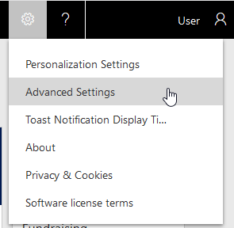

1. Click the arrow to the right of **Settings**

Settings

1. Click **Solutions**.

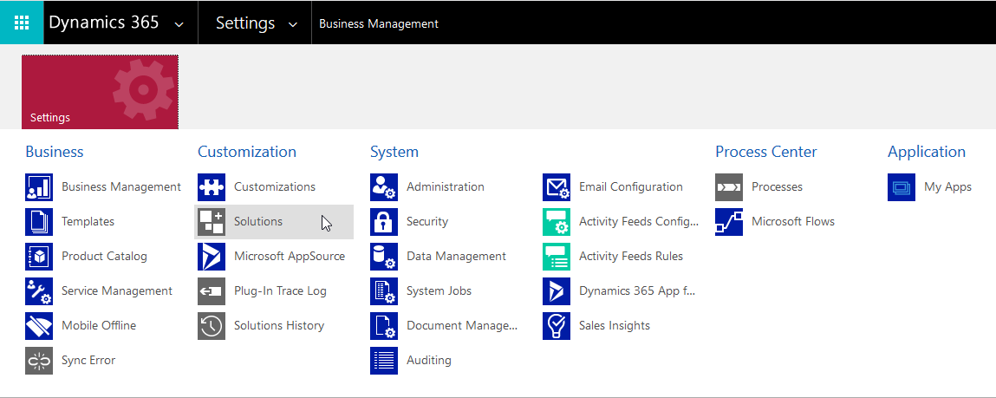

1. Click **Import**.

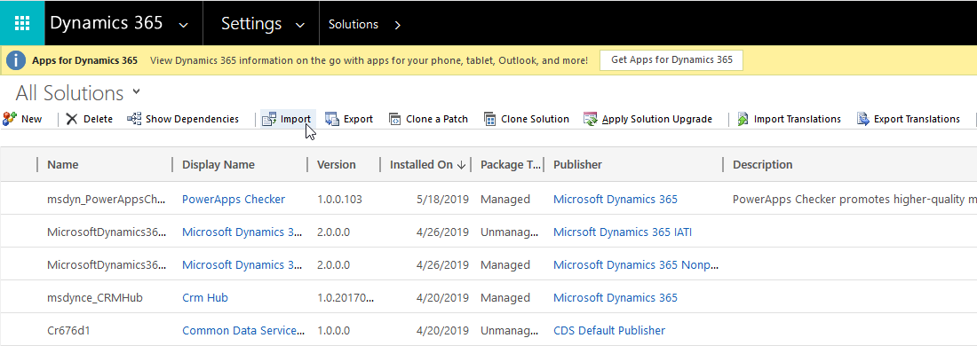

1. If this is a new install, Browse to the **Common Data Model for Nonprofits Core** and then click **Next.** If this is an upgrade, you will want to follow the steps to upgrade the core.

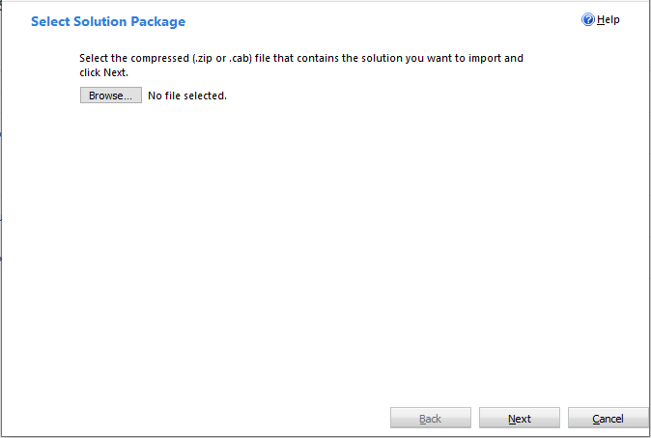

1. Click **Import.**

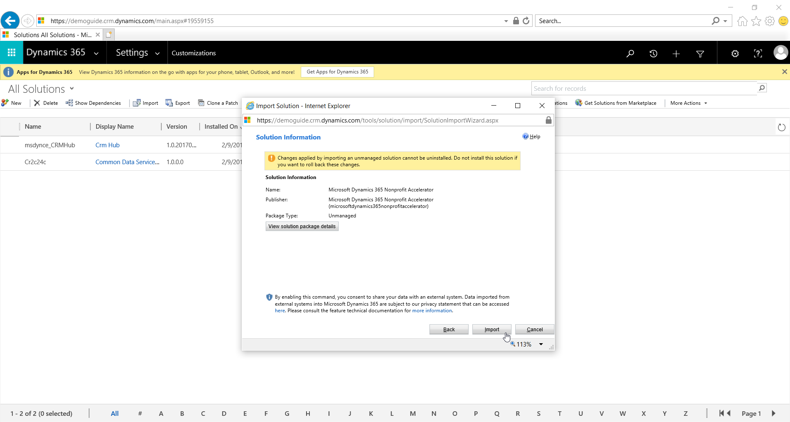

1. Wait until the process completes.

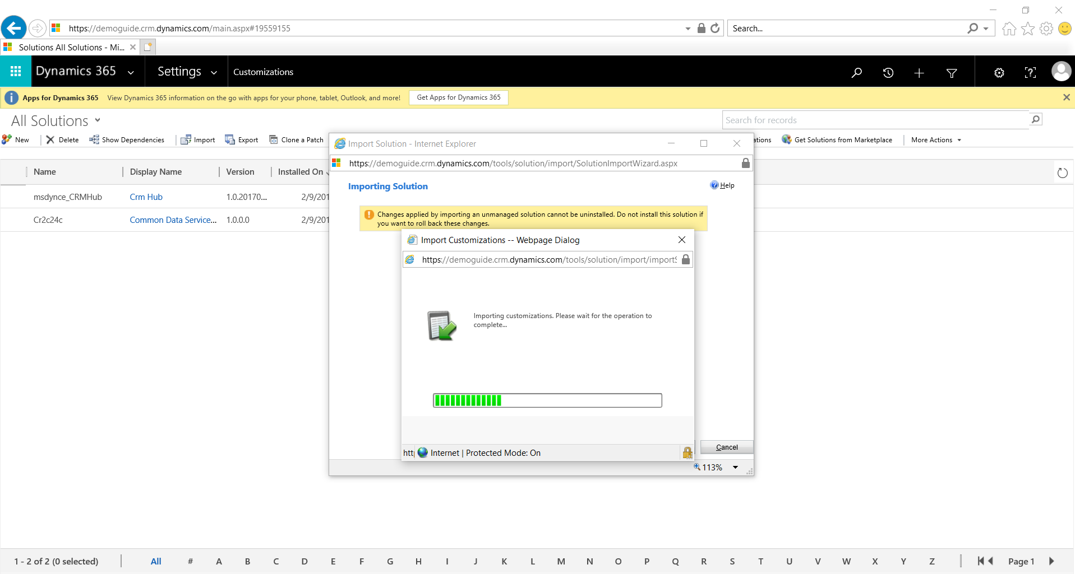

1. Click **Publish All Customizations**.

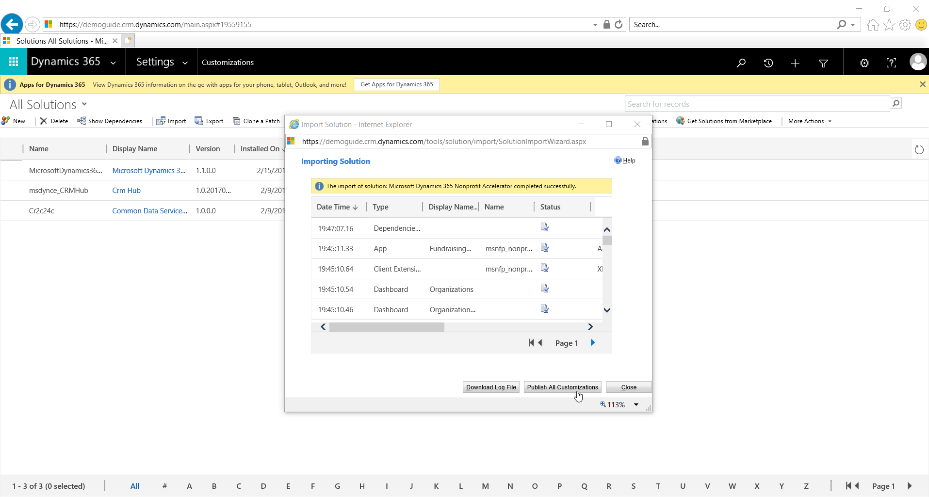

1. Optionally, repeat steps 6 to 10 for the **Common Data Model Nonprofit Sample Apps** if you want sample apps.

# Import Solutions Using the Package Deployer

The package deployer is a advanced tool that can be used in certain mass deployment scenarios or other specific packaging scenarios.

## Download the Package Deployer

1. Navigate to the Nonprofit Accelerator GitHub
2. Download the “**PackageDeployer”** and **“**NFP.Accelerator.-.Package.Deployer.Solution” zips
3. Extract the Zip files in a new folder



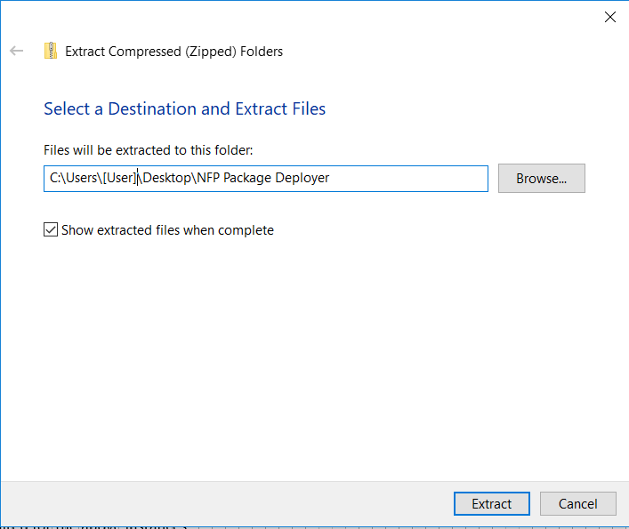

## Solution Options

The Nonprofit Accelerator consists of the below solution packages:

**NonprofitCore** – This package represents the Common Data Model for Nonprofits and contains the essentials for the Nonprofit Accelerator including views, forms, and tables. This solution does not have dependencies with the Sales module, so no connection with campaign, lead, opportunity or product are made.

**CommonDataModelforNonprofitSampleApps** – Contains the sample apps for the nonprofit core.

**NonprofitIATI** - Contains additions to the core to improve the IATI compliance, including: IATI xml file export and the non-embedded sync process features.

**NonprofitIATISampleApps** – Contains the sample apps for the Nonprofit IATI solution.

**Note**: These solutions **may have** dependencies among themselves *and / or other modules. Please refer to the Deployment Solution Dependencies diagrams*.

**Sample *Apps Note:*** *If you are updating from a version of the core prior to 2.3.3.0 the package deployer will automatically install the sample app base solution to preserve sample from previous versions. If you wish to remove the sample apps please review the upgrade guide for steps to do so.*

**Dynamics 365 Nonprofit Accelerator v3.0 Solution Dependencies**

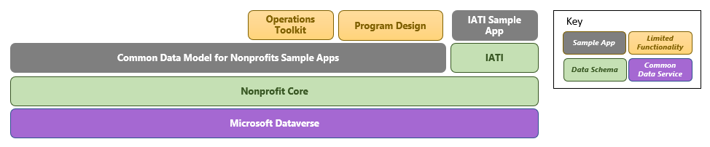

## Package Deployment

1. Extract the NonprofitAccelerator-Package Deployer and Copy **the PkgFolder** and the .dll file

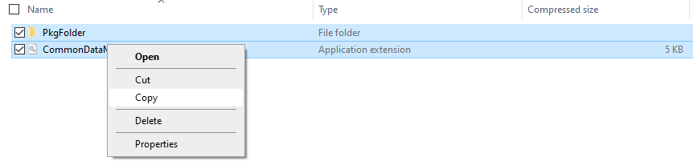

1. Paste the PkgFolder and .dll file in the “PackageDeployer” Folder

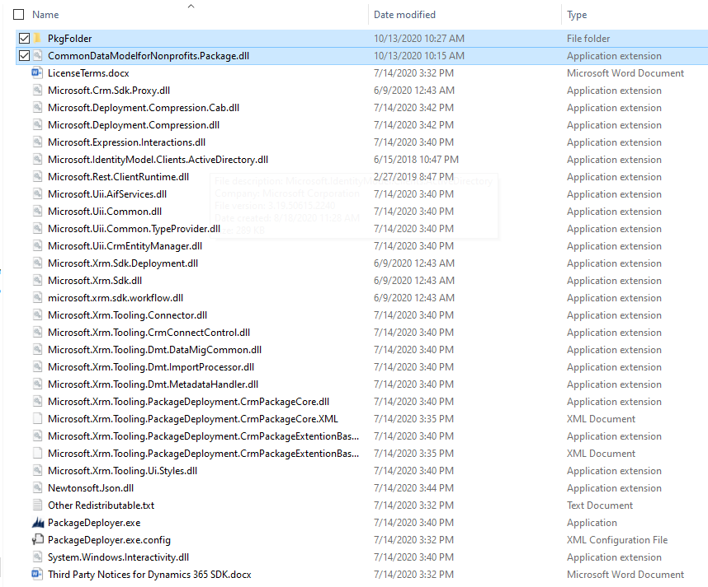

1. Unblock the “CommonDataModelforNonprofits.Package.dll”
   1. Right click the “CommonDataModelforNonprofits.Package.dll”
   2. Click on properties
   3. Check the Unblock box
   4. Click Ok

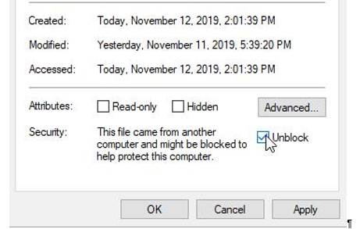

1. Run the PackageDeployer.exe with command prompt
   1. The format for the command should be as follows, with settings separated by the pipe character*:”.\PackageDeployer.exe /Settings:"*NonprofitCoreAnchor=true |*NonprofitCore=true |*CommonDataModelNonprofitSampleApps=true *|NonprofitIATI=true |NonprofitIATISampleApps=true |SkipSampleData=false* "
   2. Note the options available to you for installing correspond to the solutions mentioned at the beginning of this document, they are:
      1. NonprofitCoreAnchor
         1. When set to true, this will install the NonprofitCoreAnchor solution to the target environment.
      2. NonprofitCore
         1. When set to true, this will install the NonprofitCore solution to the target environment.
      3. NonprofitIATI
         1. When set to true, this will install the MicrosoftDynamics365IATI solution to the target environment.
      4. CommonDataModelforNonprofitsSampleApps
         1. When set to true, this will install the Common Data Model for Nonprofit Core Sample Apps solution to the target environment.
      5. NonprofitIATISample Apps
         1. When set to true, this will install the Common Data Model for Nonprofit IATI Sample Apps solution to the target environment.
      6. SkipSampleData
         1. When set to false, sample data will be installed
2. Click **Continue** on the main screen of the tool

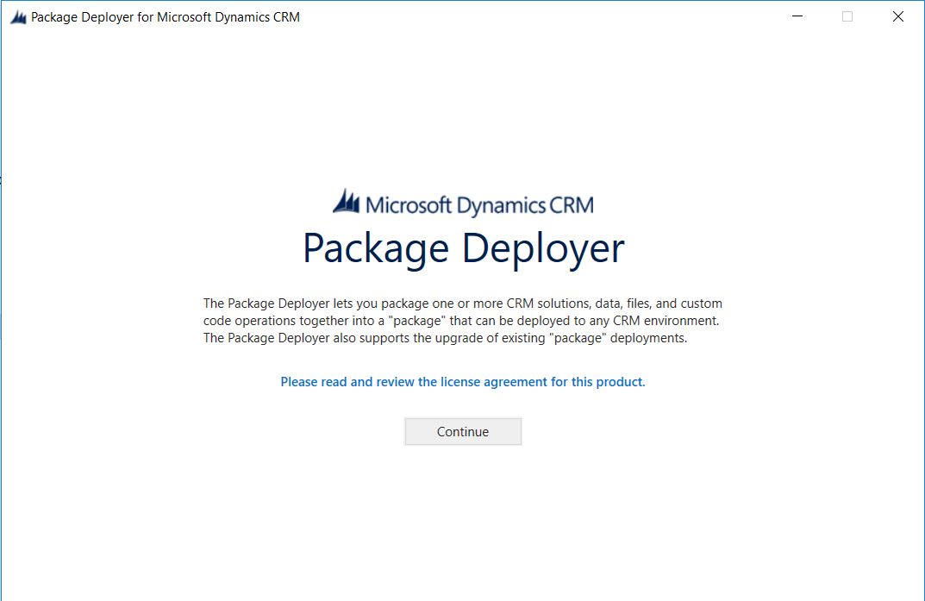

1. Login with your Office 365 credentials

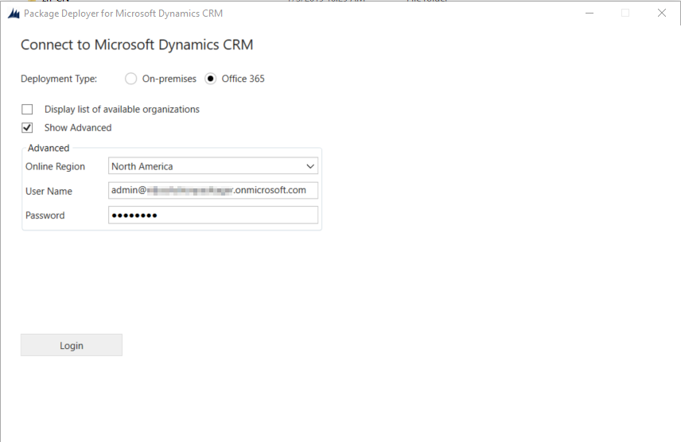

1. Click next until getting into the Executing Install Actions window
2. After the process is complete click next > Finish

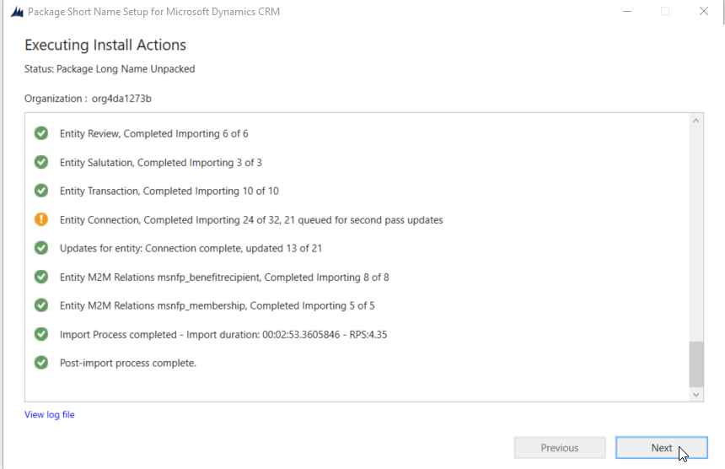

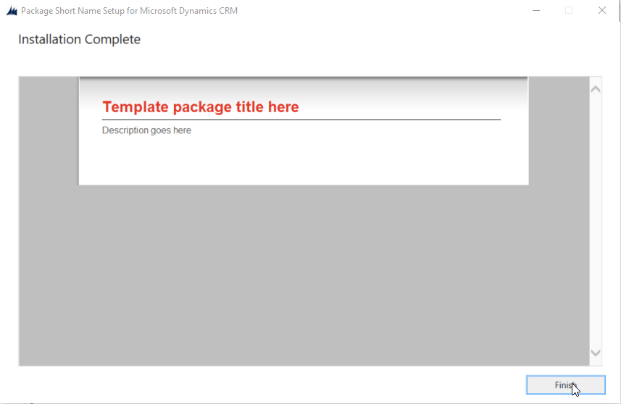

1. Go to the environment and make sure that the **solutions** were installed properly

# SDG Sync Process

The SDG synch is process that will import the latest SDG goals, targets, and indicators from the UN website as measurement items for use with program design solutions.

## Configure SDG Sync Process (solution-based)

1. Go to [https://make.powerapps.com](https://make.powerapps.com/)

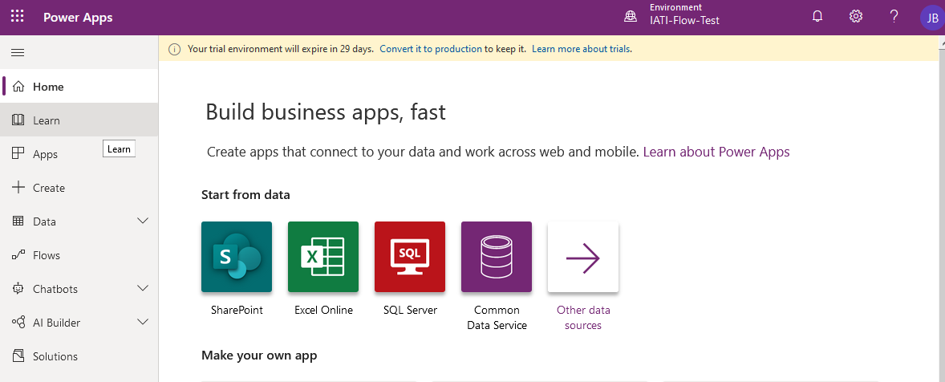

1. Click on **Environment** and ensure the correct Dynamics 365 environment is selected.

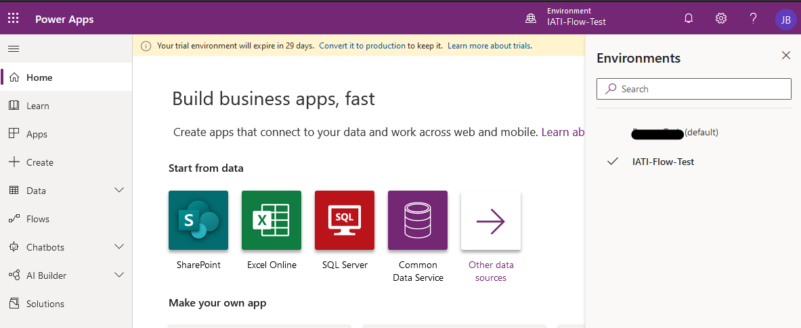

1. Click on **Solutions**.

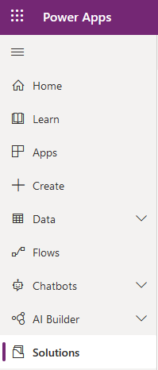

1. Click on the **Microsoft Dynamics 365 Measurement** solution.

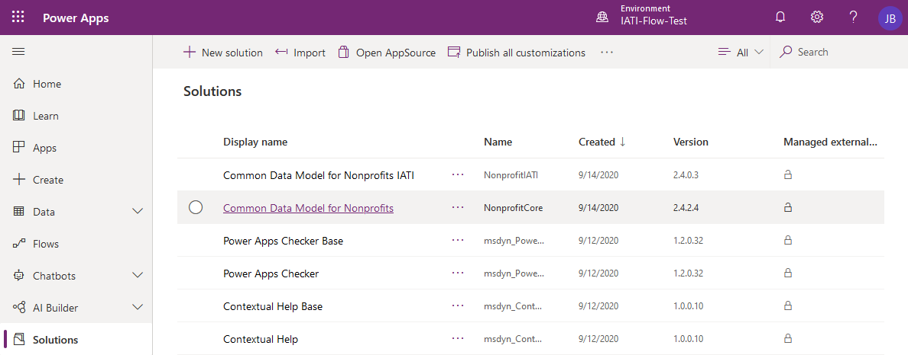

1. Find and click on the **SDG Synch** component.

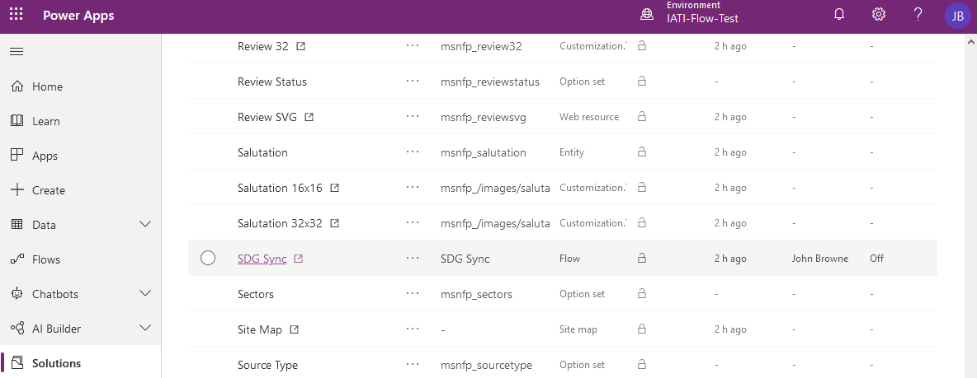

1. A new Flow tab/window will open. Ensure the Flow is disabled by clicking the **Turn off** button. If the only option available is to **Turn on** the Flow, skip this step.

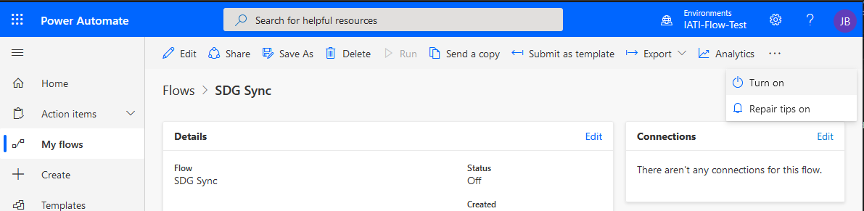

1. Click **Edit**.

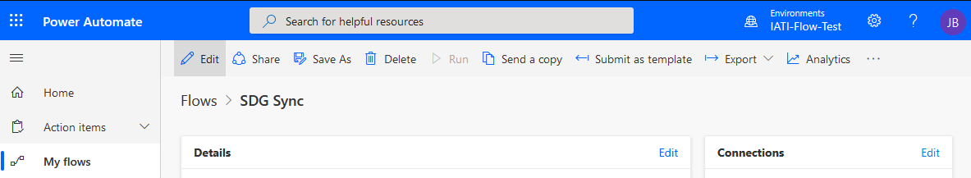

1. Expand the two **Connections** components by clicking on them.

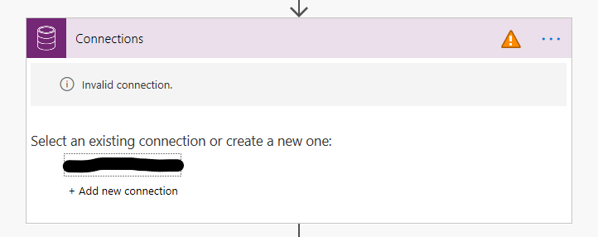

1. **Select** the correct connection from the list or create a new one by clicking **Add new connection**.



1. Expand the following three sections by clicking on them and complete the following steps **Condition LookforSDGLibrary less than 1**, **Apply to each Goal**, **Apply to each Target**, **Apply to each Indicator**.

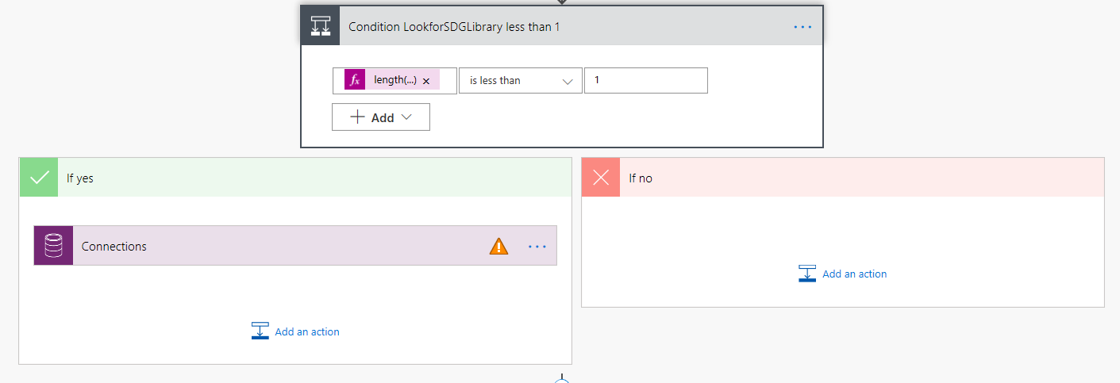

1. Expand the **Connections** Component and Select the correct connection from the lit or create a new one by clicking **Add new connection**



1. Expand the following three sections by clicking on them and complete the following steps **Apply to each Goal**, **Apply to each Target**, **Apply to each Indicator**.

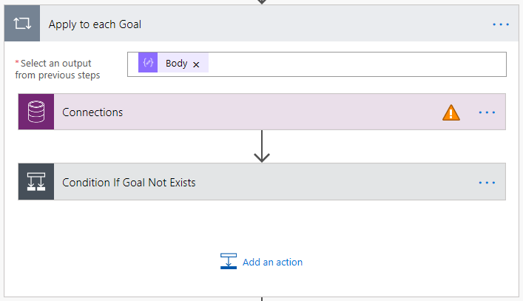

1. Expand the **Connections** Component and Select the correct connection from the list or create a new one by clicking **Add new connection**



1. Expand the **Condition If (Goal,Target, or Indicator) Not Exists**, directly below Connections and Expand the **Connections** Components and Select the correct connection from the list or create a new one by clicking **Add new connection**

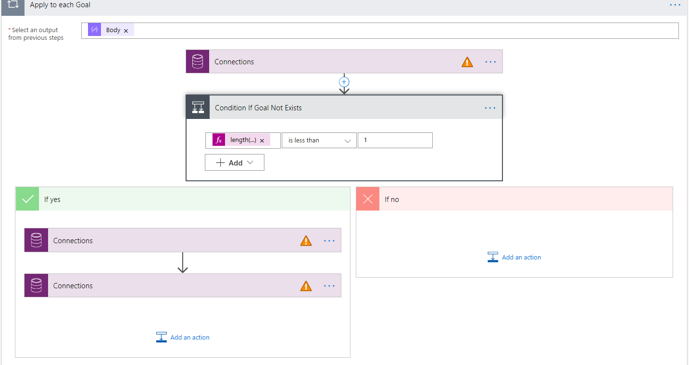

1. Ensure you complete steps 12 through 14 for each of the following sections **Apply to each Goal**, **Apply to each Target**, **Apply to each Indicator.**
2. Click **Save**
3. In the top left click the back arrow.

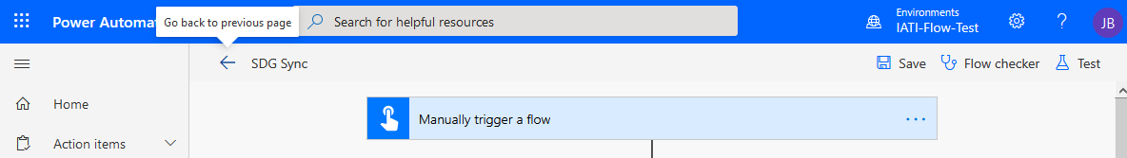

1. Along the top bar find and click **Turn On**

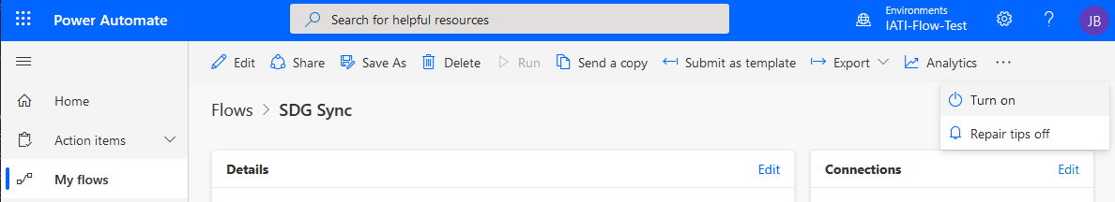

## Execute SDG Sync Process (solution-based)

1. Navigate to the **SDG Sync** flow by following steps 1-5 of the **Configure SDG Sync Process (solution-based)**guide.
2. Click **Run**.

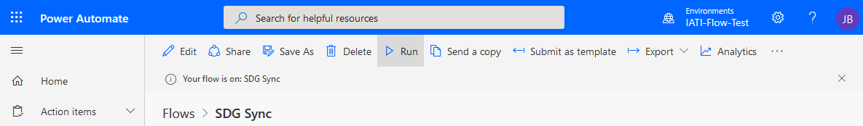

1. Ensure the correct **connection** is selected and click **Continue** if presented with the following confirmation window.

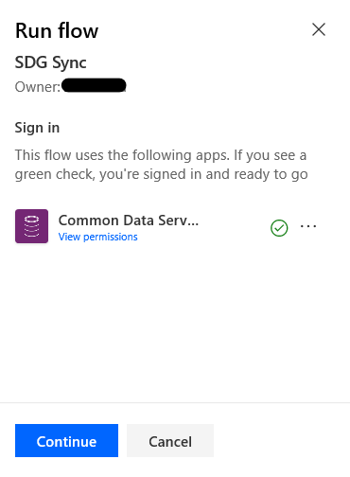

1. Click **Run flow**.

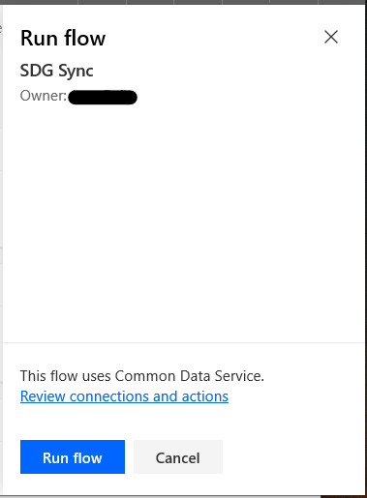

1. Click F**low Runs Page** if you wish to monitor the flow execution.

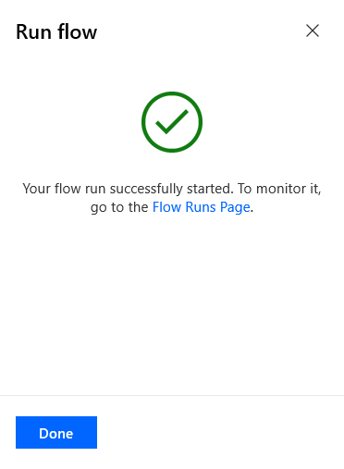

1. A list will display the flow’s execution history and the status of each run. Allow between **1 and 4 hours** for the process to complete. Time will vary depending on the current load on Dynamics 365.

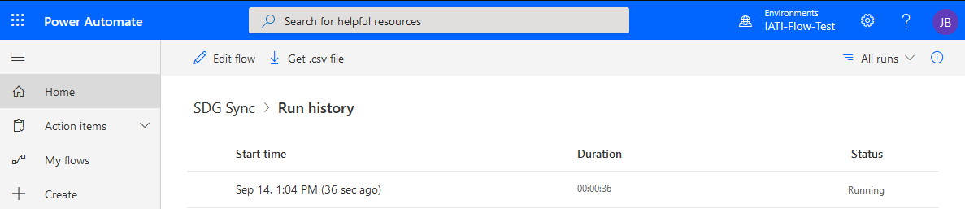

# Program Design Canvas App

## Import Program Design Canvas App

1. Go to[**https://github.com/microsoft/Industry-Accelerator-Nonprofit/**](https://github.com/microsoft/Industry-Accelerator-Nonprofit/).
2. Navigate to Releases.
3. Download the latest **Program Design zip** file
4. Go to [**https://make.powerapps.com**](https://make.powerapps.com)
5. Select Apps
6. Click on **Environment** and ensure the correct Dynamics 365 environment is selected.

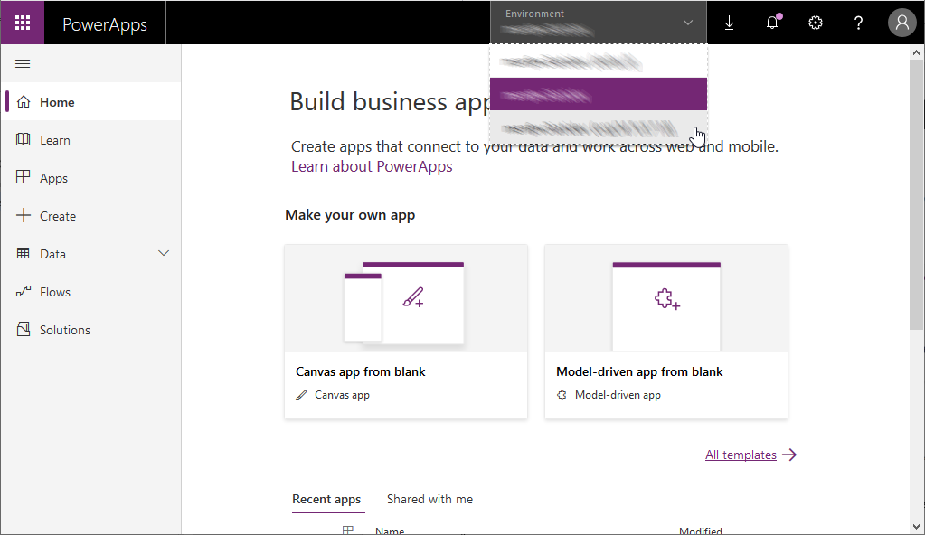

1. Click **Import Canvas App**

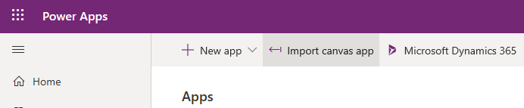

1. Click **Upload**
2. Navigate to and Open the Program Design Zip file previously downloaded
3. Wait for the **Review Package Content** tab to appear

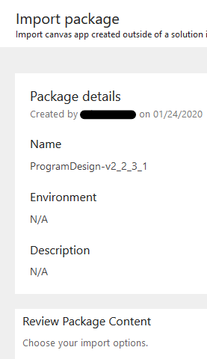

1. For each red exclamation row, click the blue text in the **IMPORT SETUP** column.

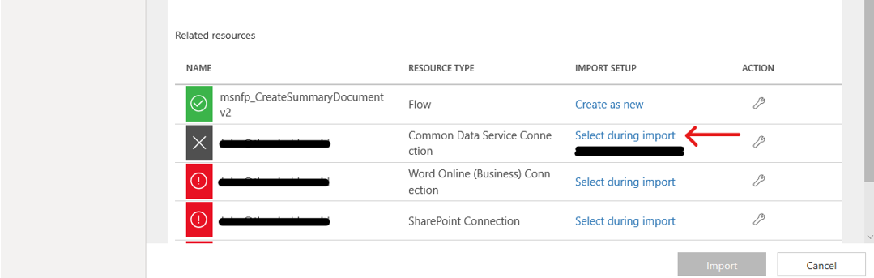

1. Select Create and Name each app and flow
2. Add any connections required
3. When all the red exclamation marks are gone, Click Import
4. When the app has completed importing click Apps

## Enable Browser Zoom

In its current form the template app will not allow browsers to zoom. This is a result of the app having the aspect ratio locked. Implementer will need to balance the pros and cons of each one of these settings. You can enable Browser Zoom using the following steps.

1. Go to [**https://make.powerapps.com**](https://make.powerapps.com)
2. Select **Apps**
3. Click on **Environment** and ensure the correct Dynamics 365 environment is selected
4. Find the copy of the Program Design App you have imported
5. Click the elipsce next to the name of the app and select **Edit**

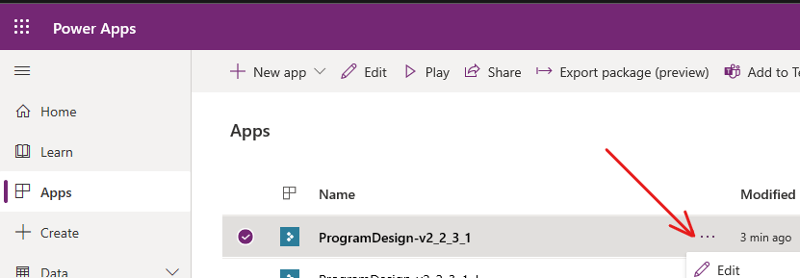

1. After the app opens, in the top left click **File**
2. Click **Settings**
3. Click **Screen size + orientation**
4. Scroll down, and under Advanced Settings disable **Scale to fit**

## Add SDG Icon Images

1. Go to <https://github.com/microsoft/Industry-Accelerator-Nonprofit/>. Download “SDG_Icons.zip.”
2. Go to your organization’s Dynamics 365 Customer Engagement portal (e.g. <https://organizationid.crm.dynamics.com>).
3. Open the “NonProfit Hub” App.
4. On the left side, scroll down, and click to navigate to the Measurement Items

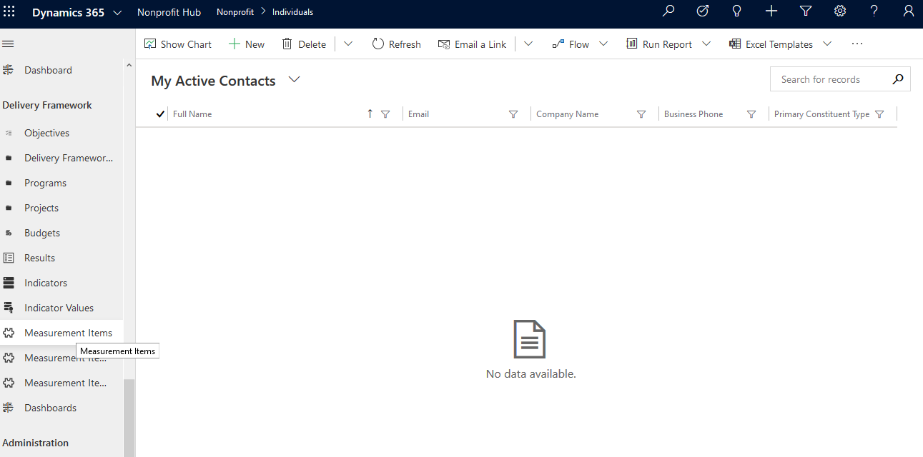

1. Change the view to goals

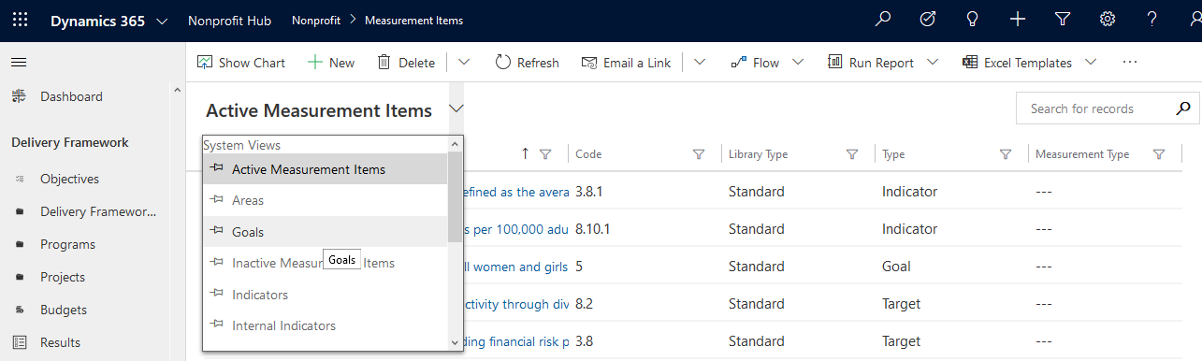

1. Sort by Code, by clicking the sort header

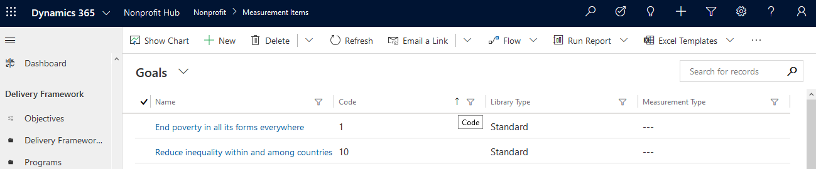

1. Click “End Poverty in all its forms everywhere” to open the record

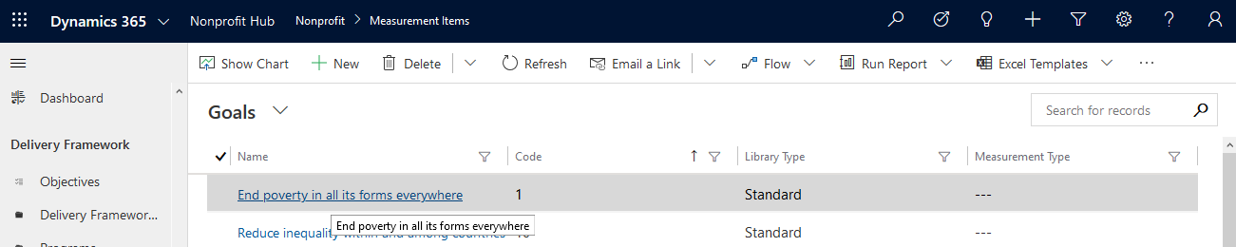

1. Click the circular icon left of the record name (With “EP” inside)

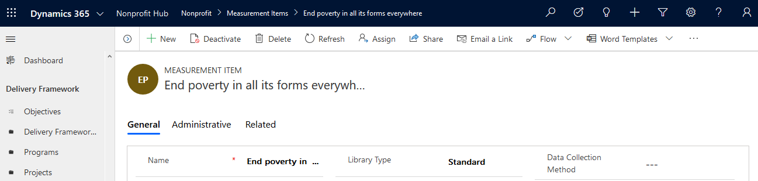

1. Click **Upload Image**

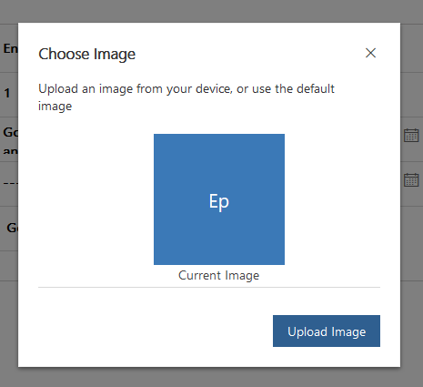

1. Navigate extracted content of the “SDG_Icons.zip.” and select the appropriate icon.
2. Click **Change**

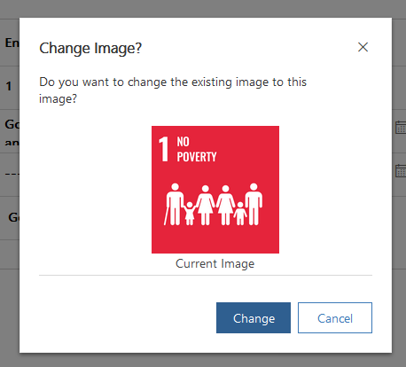

1. In the top left, next to the new button, click carrot to expand the goal list and navigate to each goal repeating setps #8-11

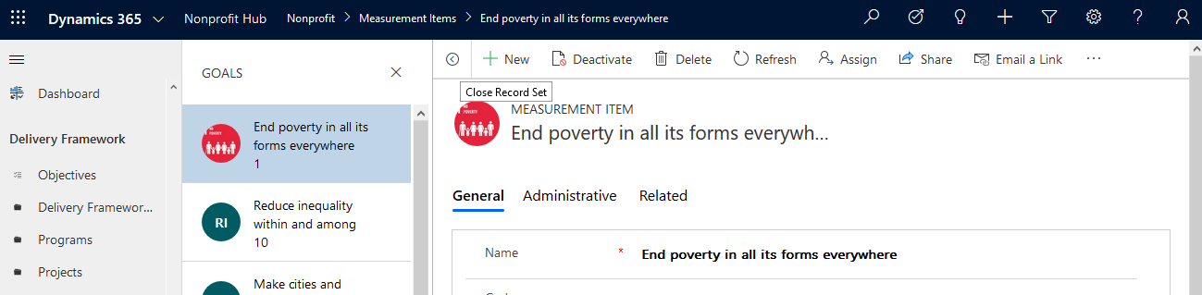

## Configure Document Creation Process

1. Go to <https://github.com/microsoft/Industry-Accelerator-Nonprofit/> and download **NonprofitAccelerator_CDS_ProgramDesign_Flow_msnfp_CreateSummaryDocument_Template.docx**
2. Copy and paste the **NonprofitAccelerator_CDS_ProgramDesign_Flow_msnfp_CreateSummaryDocument_Template.docx** word template into a sharepoint folder (make note of the location)
3. If you have not already imported the Program Design App complete the step under the Section: **Import Program Design Canvas App**.
4. Navigate to <https://powerautomate.microsoft.com>
5. Click **My Flows** (Ensure you are in the correct environment)
6. Open the flow that was imported and click **Edit**
7. Expand the **Populate a Microsoft Word Template** section
8. Clear the **Location** field by clicking the X on the right
9. Select the Sharepoint Site where you placed the word template
10. Clear the **Document Library** field by clicking the X on the right
11. Select the Library that the word template is in
12. Use the folder icon to navigate to and select the word template

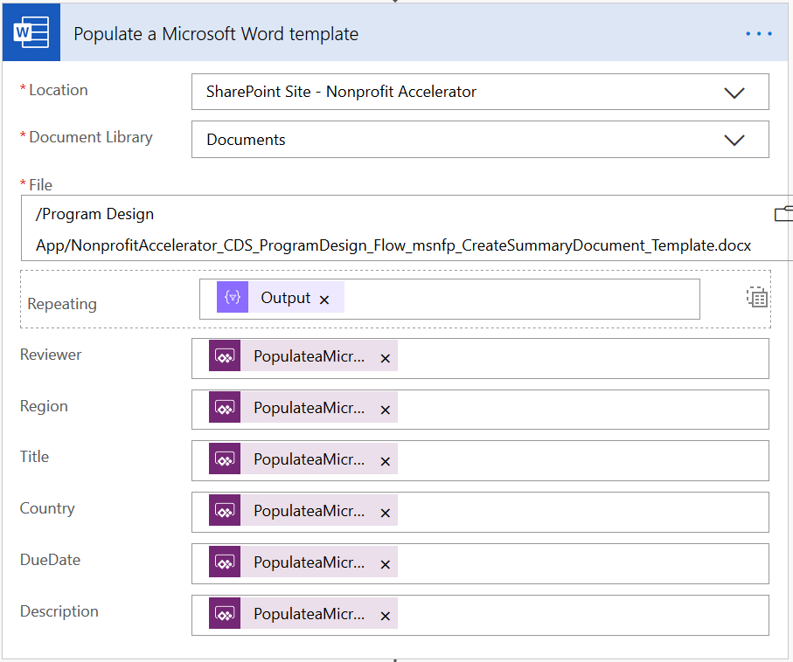

1. Scroll down and Expand **Create File**
2. Clear the **Site Address** field by clicking the X on the right
3. Select a site where you would like new word documents created
4. Use the folder icon to navigate to the specific folder you would like the word documents place in

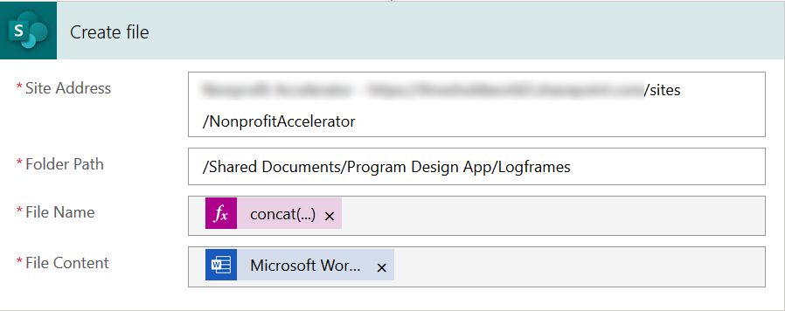

1. Scroll down and Expand the Condition and expand **Send an email (V2)**
2. In the body update the **href** address to correspond to the Sharepoint site you selected in Create file.

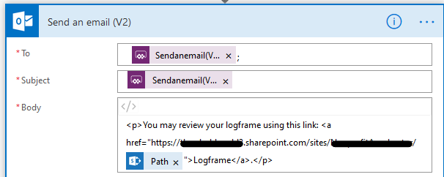

1. Under If no, expand **Respond to a PowerApp or flow** and update the path that is listed in the component to correspond to the sharepoint site you selected in Create file.
2. Click **Save**
3. Click the back Arrow

## Branding the Program Design App

The program design app comes with the ability to easily adapt the look and feel of the app. This can be done following the steps below. To do this you will need a RGBA code color that you would like to use and if desired a logo in an image file.

1. Navigate to <https://make.powerapps.com/>
2. In the top right, click **Environment** and select the environment that you imported the Program design app into.
3. On the left, select **Apps**
4. Find the Program Design App in the list and to the right click the ellipse and click **Edit**
   1. If this is the first time you are opening the app it will prompted for permissions click Allow
5. In the screen that loads, click **File**
6. Click **Media**
7. Click **Browse**, then navigate and open your logo image file (note the name of your file)
8. Click **Close**
9. In the screen that loads, click the **App**

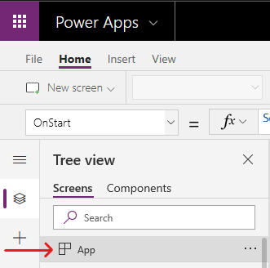

1. Expand the formula bar and enter your RGBA code.

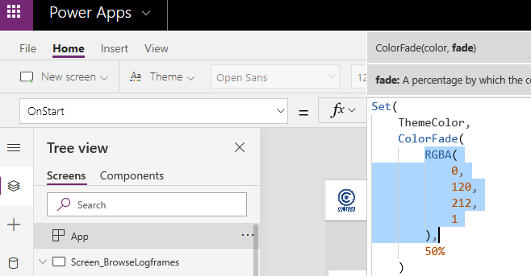

1. If you have uploaded a logo file you can also enter the name of your logo file to update the logo.

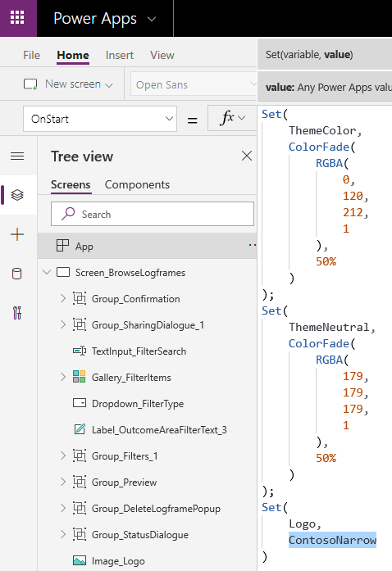

1. In the top left, click file
2. Click Save
3. Click Publish

## Program Design App Mapping

There are several pages within the Program Design App that map item back to the data in the NFP CDM. Below is a quick mapping of some of those items.

#### 1-Browse Logframe

|  |  |  |  |
| --- | --- | --- | --- |
| **Screen** | **Field Description** | **Data Source** | **Field Data** |
|  | Search | "" |  |
|  | Filters | OptionSet_MeasurementType | Outcome Area, Outcome, Indicator |
|  | Status | OptionSet_LogframeStatus | Approved, Reviewer Progress, Reviewer Not Started |

#### 2-Build a Logrframe

|  |  |  |  |
| --- | --- | --- | --- |
| **Screen** | **Field Description** | **Data Source** | **Field Data** |
| Enter Project Information | Project Title | SelectedLogframe.Name | Text |
|  | Project Goal | SelectedLogframe.Goal | Text |
|  | Region | SelectedLogframe.Region | Text |
|  | Country | SelectedLogframe.Country | Text |
|  | Logframe Due | SelectedLogframe.'Planned End Date' | Calendar |
|  | Project Start | SelectedLogframe.'Start Date' | Calendar |
|  | Project End | SelectedLogframe.'End Date' | Calendar |
|  | Donor | [@'Delivery Frameworks'].Donor |  |
|  | Reviewer | [@'Delivery Frameworks'].Reviewer |  |
| Add Outcome | Outcome Areas | 'Measurement Items (Views)'.Areas | Business, Education, Health, Power, Safety |
|  | Indicator Library | 'Measurement Item Types'.Library | SDG's, Sustainable Development Goals |
|  | Individual SDGs | selectIndicatorMIR | There are 17 of these |
|  | Notes | currentResult.msnfp_description | Text |
| Add Outputs & Activities | Description | Gallery_Step3Outputs.Selected.Result.Description | Text |
| Preview Logframe | Reviewer | [@'Delivery Frameworks'].Reviewer |  |

#### 3-My Logframes

|  |  |  |  |
| --- | --- | --- | --- |
| **Screen** | **Field Description** | **Data Source** | **Field Data** |
| My Logframes |  |  |  |
| Filter |  |  |  |
|  | Created by | 'Users (Views)'.'Enabled Users' |  |
|  | Reviewer | 'Users (Views)'.'Enabled Users' |  |
|  | Status | OptionSet_LogframeStatus |  |
|  | Date Range Start | First(Filter(Filters, Type="DueDate")).Value |  |
|  | Date Range End | First(Filter(Filters, Type="DueDate")).ValueTo |  |

#### 4-Browse Indicators

|  |  |  |  |
| --- | --- | --- | --- |
| **Screen** | **Field Description** | **Data Source** | **Field Data** |
|  | Indicator Type | [@'Measurement Items'].'Library Type' |  |
|  | Outcome Area | Filter( colGoalsAreas, 'Library Type' = ComboBox_IndicatorLibraryType.Selected.Value ) |  |

# IATI Codelist Sync

## Configure IATI Codelist Sync Process (solution-based)

Use this guide if you wish to keep the Flow as part of the Nonprofit IATI solution. With this configuration, if the IATI solution is updated, the process will also be updated (i.e. any modifications/customizations will be lost). If you wish to install the process on a different environment, or to be able to customize the process without losing changes if the IATI solution is updated, follow the **Install & Configure IATI Codelist Sync Process (standalone flow)** guide instead.

1. Go to [https://make.powerapps.com](https://make.powerapps.com/)

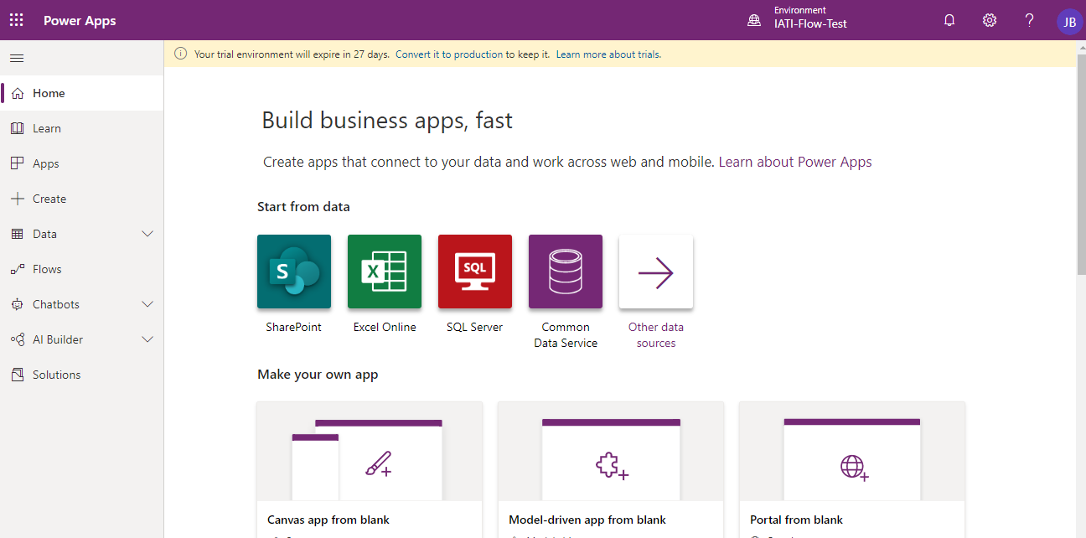

1. Click on **Environment** and ensure the correct Dynamics 365 environment is selected.

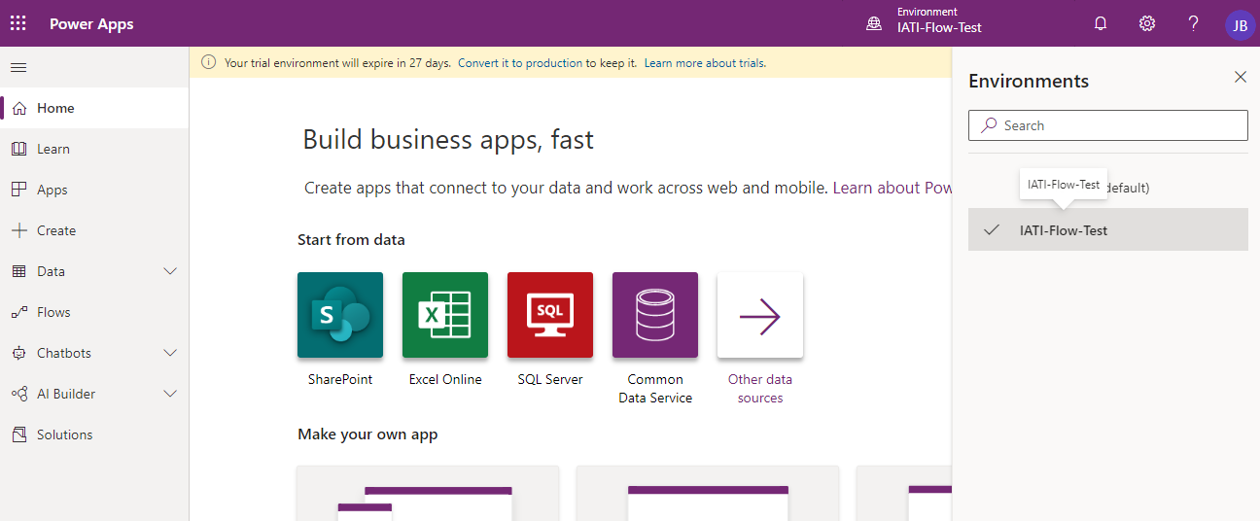

1. Click on **Solutions**.

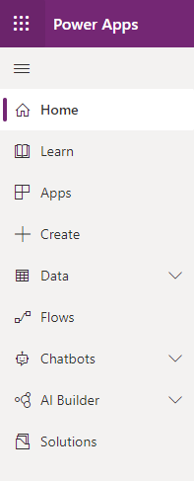

1. Click on the **Common Data Model for Nonprofits IATI** solution.

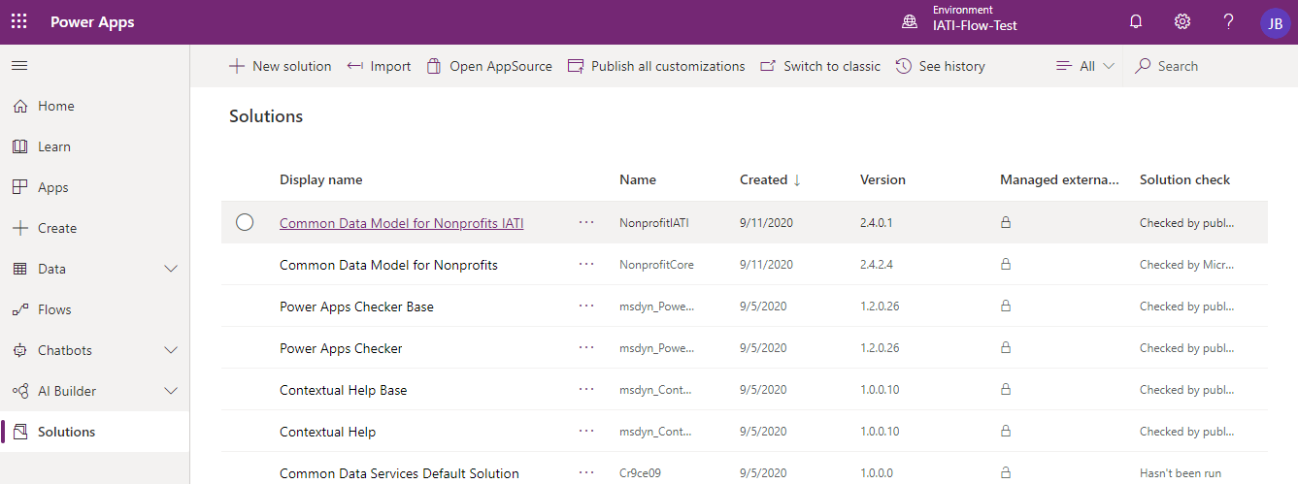

1. Find and click on the **IATI Codelist Sync** component.

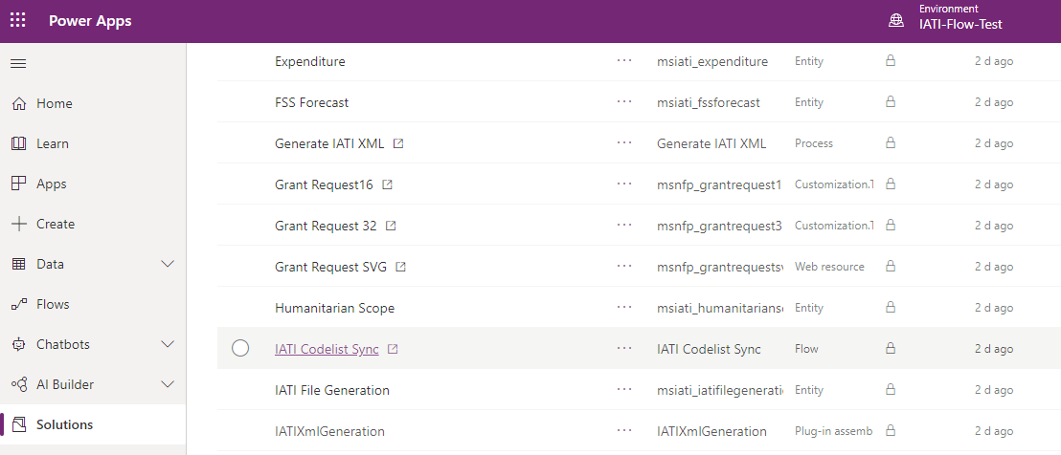

1. A new Flow tab/window will open. Ensure the Flow is disabled by clicking the **Turn off** button. If the only option available is to **Turn on** the Flow, skip this step.

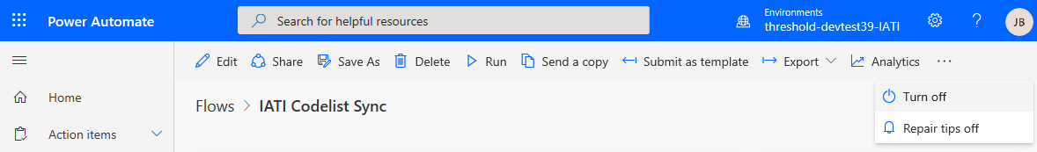

1. Click **Edit**.

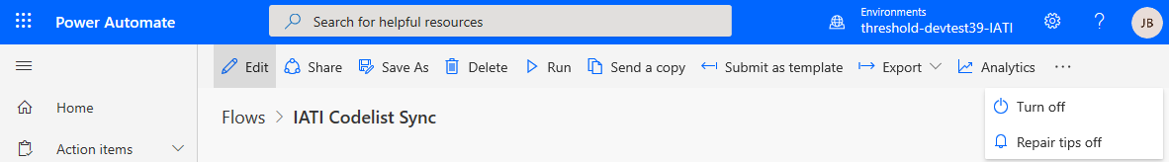

1. Click the Plus Mark on the right side

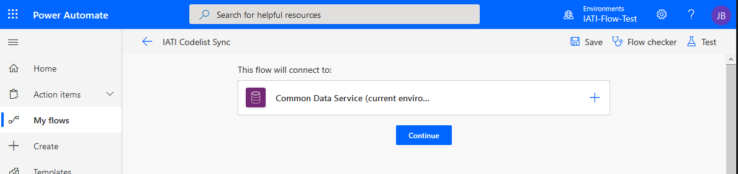

1. Wait for it to finish creating

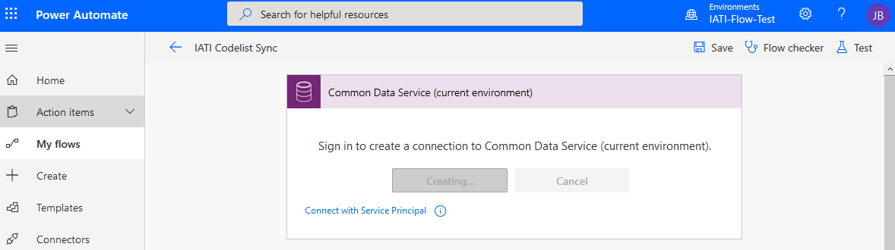

1. Click **Continue**
2. Click the **Flow Checker** button.

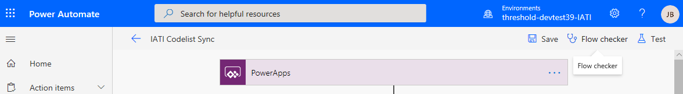

1. Ensure no **Errors** remain.

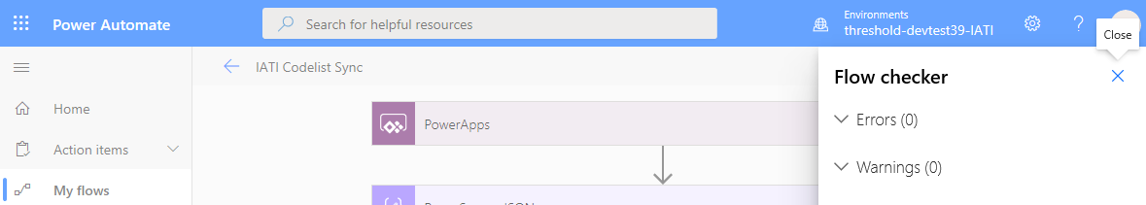

1. Click the **Save** button.

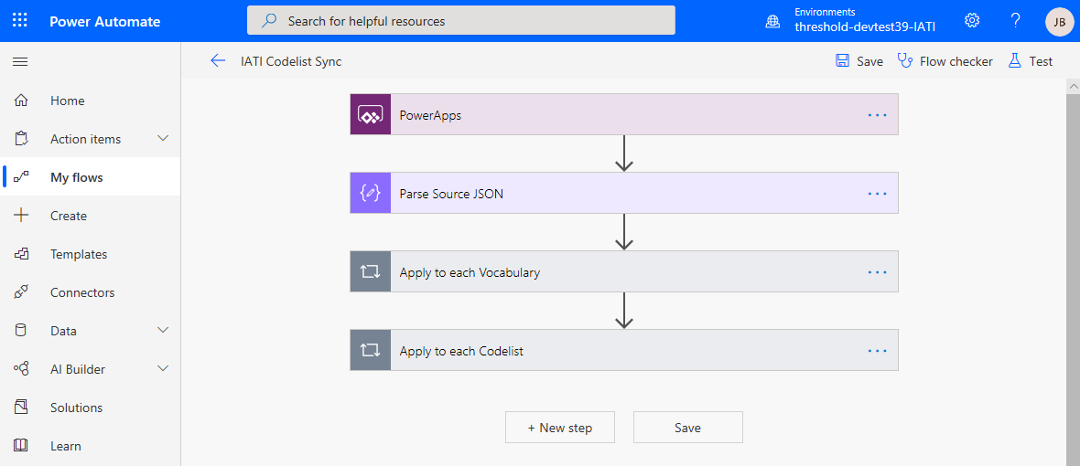

1. Click the **← (Go back to previous page)** button.

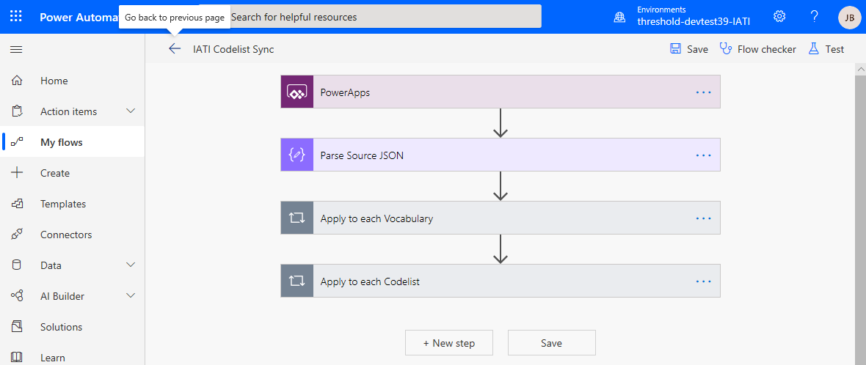

1. Ensure the process is enabled by clicking the **Turn** **On**.

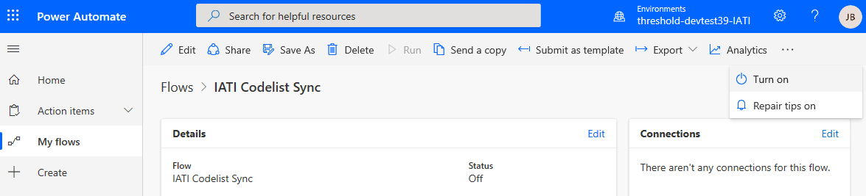

## Execute IATI Codelist Sync Process (solution-based)

1. Navigate to the **IATI Codelist Sync** flow by following steps 1-5 of the **Configure IATI Codelist Sync Process (solution-based)** guide.
2. Click **Run**.

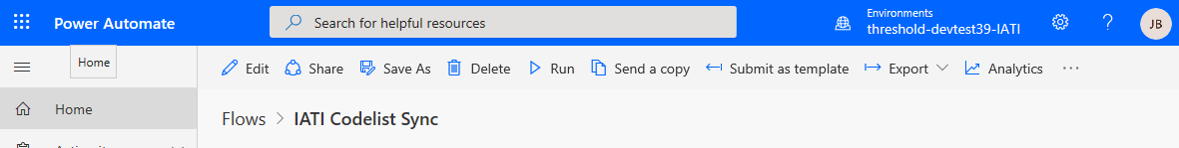

1. Click **Run flow**.

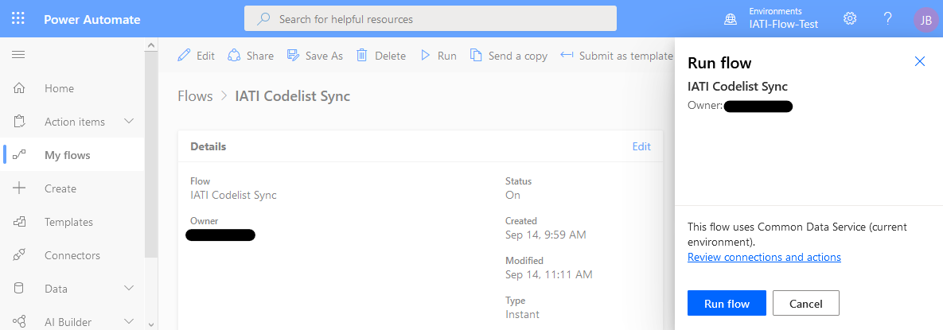

1. Click **Flow Run Page** if you wish to monitor the flow execution.

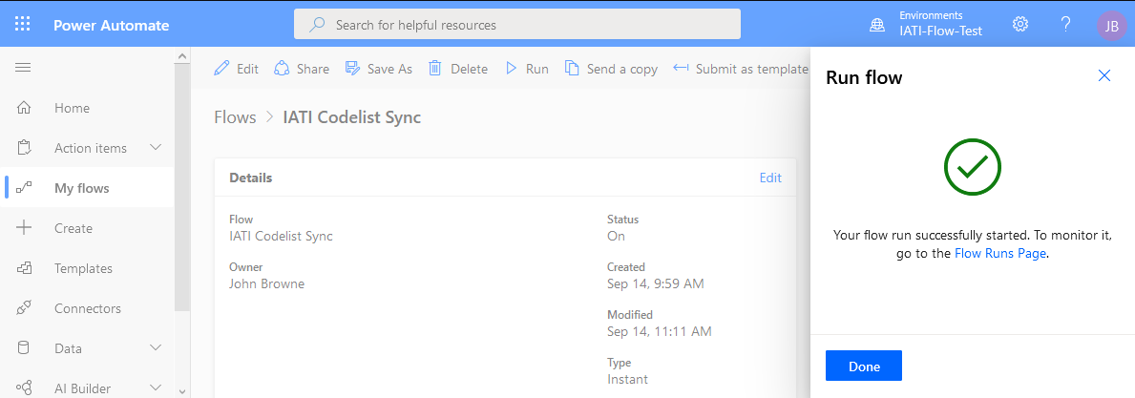

1. A list will display the flow’s execution history and the status of each run. Allow between **1 and 4 hours** for the process to complete. Time will vary depending on the current load on Dynamics 365.

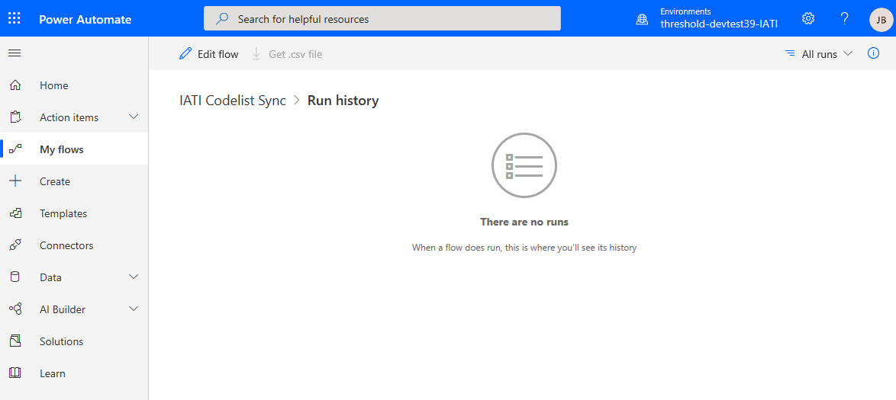

## Install & Configure IATI Codelist Sync Process (standalone flow)

Use this guide if you wish to install the process on a different environment, or to be able to customize the process and not lose any changes if the IATI solution is updated. If you wish to keep the process as part of the Dynamics 365 Customer Engagement solution, follow the **Configure IATI Codelist Sync Process (solution-based)** guide instead.

1. Go to <https://github.com/microsoft/Industry-Accelerator-Nonprofit/> and download the **IATI Codelist Sync Flow** zip file.
2. Go to [https://flow.microsoft.com](https://flow.microsoft.com/). Sign in if not already logged in.

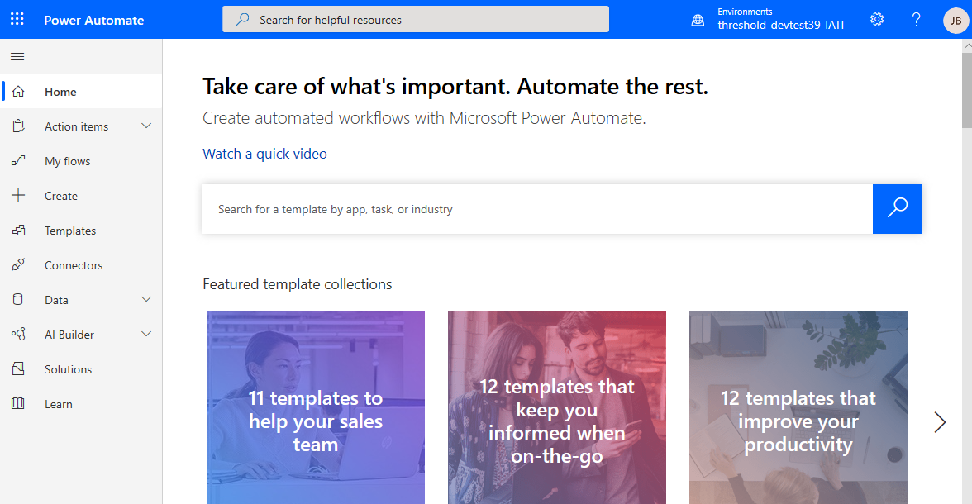

1. Click **My** **Flows**.

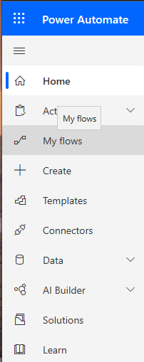

1. Click **Import**.

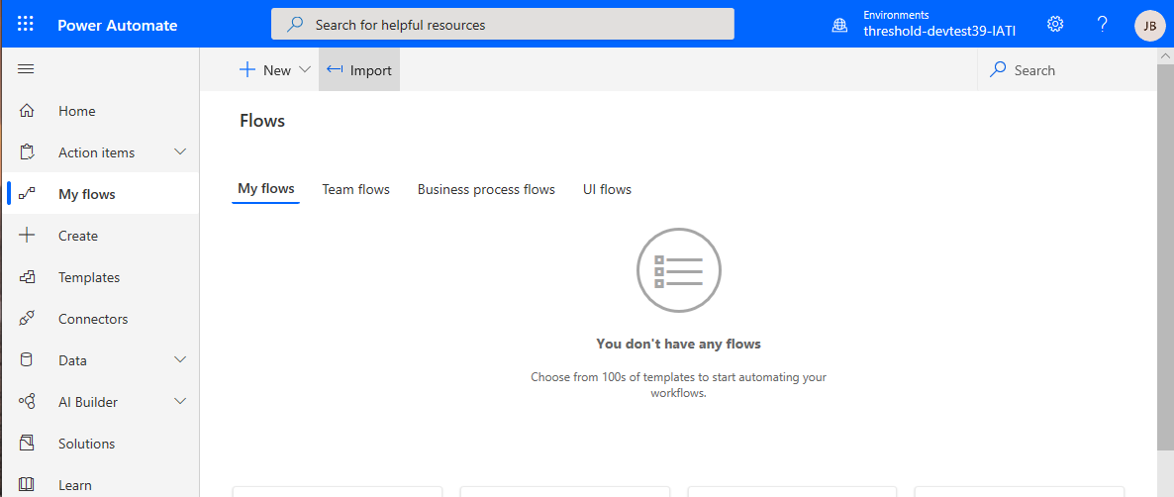

1. Click **Upload**, browse the downloaded zip file and wait for it to upload.

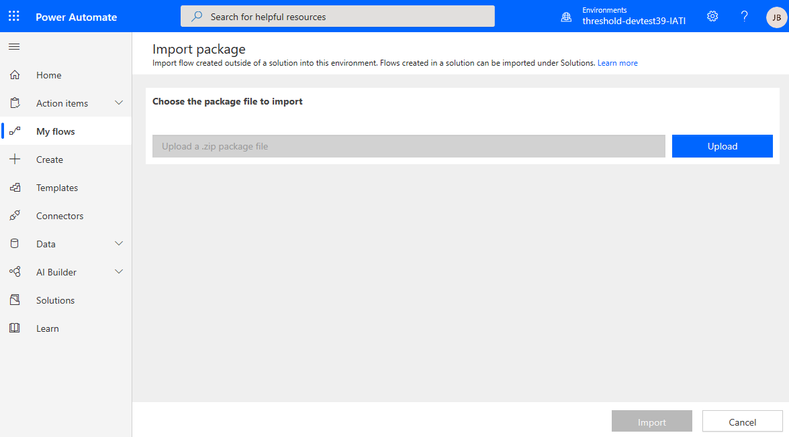

1. After the file is done uploading, you will be redirected. Scroll down to the **Review Package Content** section.

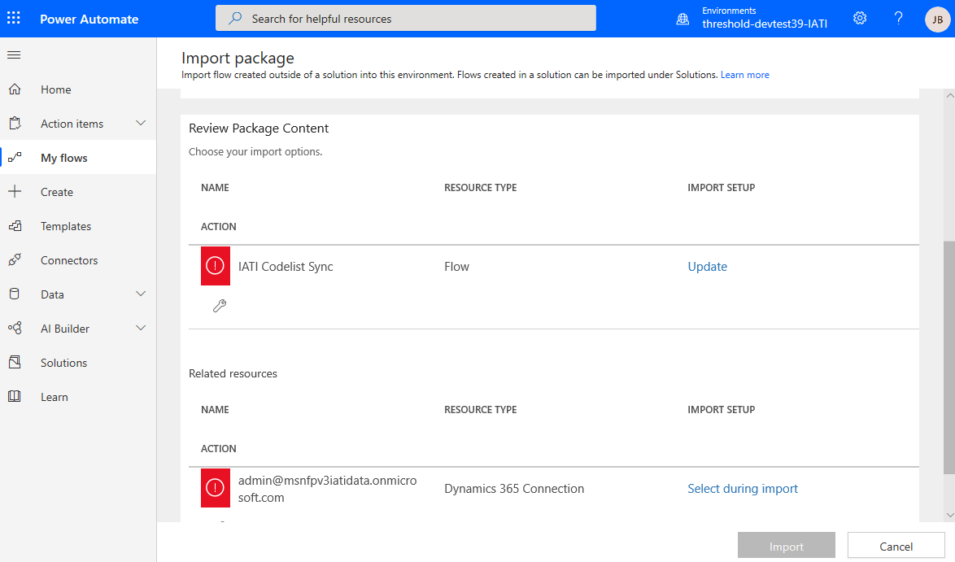

1. Click **Update** on the **Choose your import options** section.



1. If you are creating the Flow for the first time, on the **Setup** dropdown select **Create as new** and specify a **Resource name** for the flow, and then go to step 10. If updating an existing flow, skip this step.

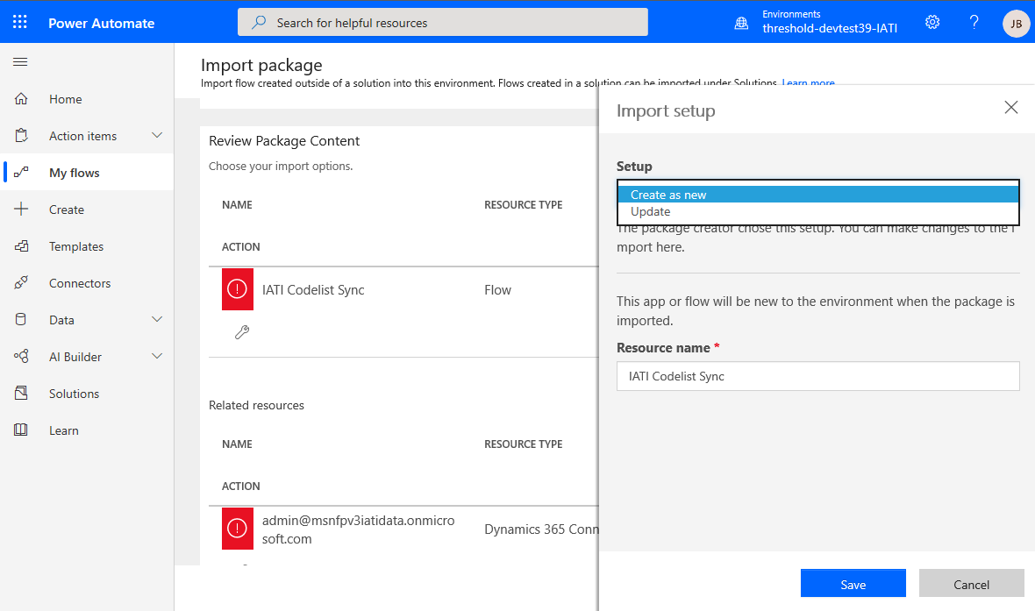

1. If you are overwriting an existing flow, on the **Setup** dropdown select **Update** and select the Flow that will be replaced.

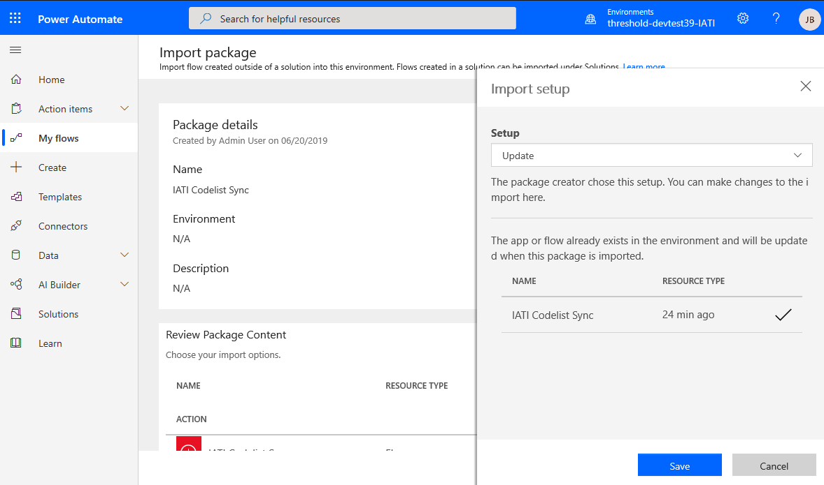

1. Click **Save**.

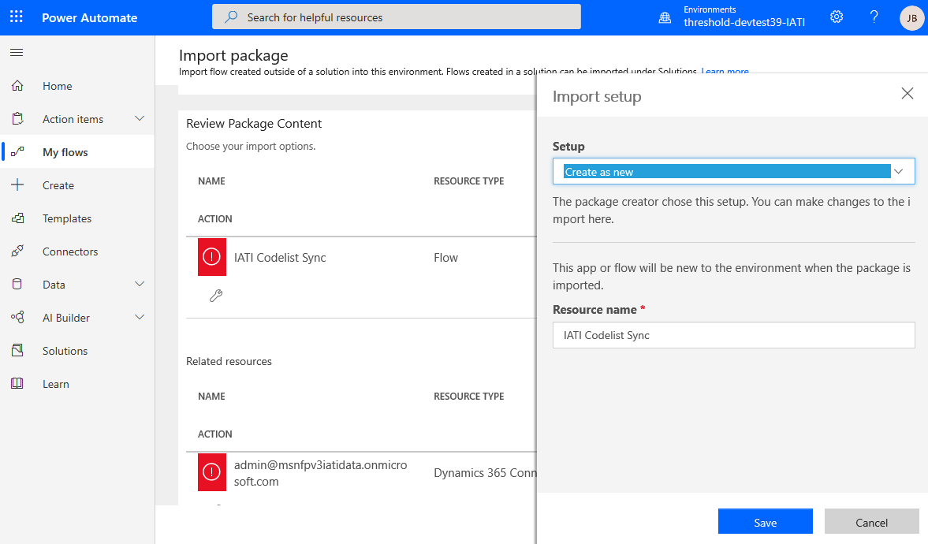

1. Click **Select during import** on the **Related resources** section.

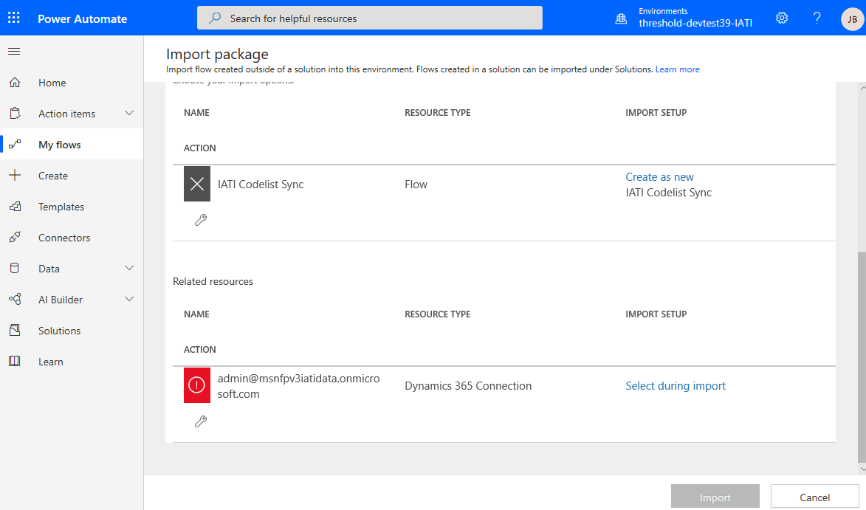

1. Select an existing Dynamics 365 **connection** or create a new one.

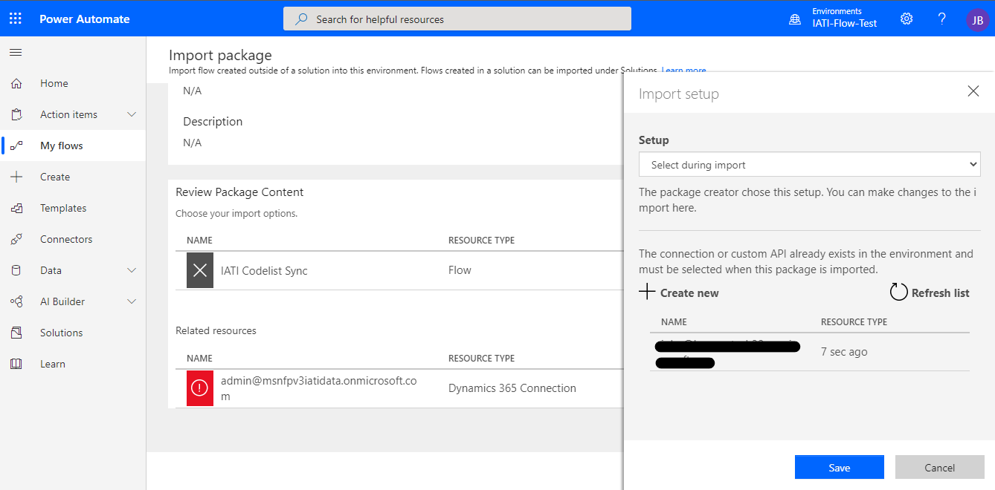

1. Click **Save**.



1. Click **Import** and wait for the process to complete.

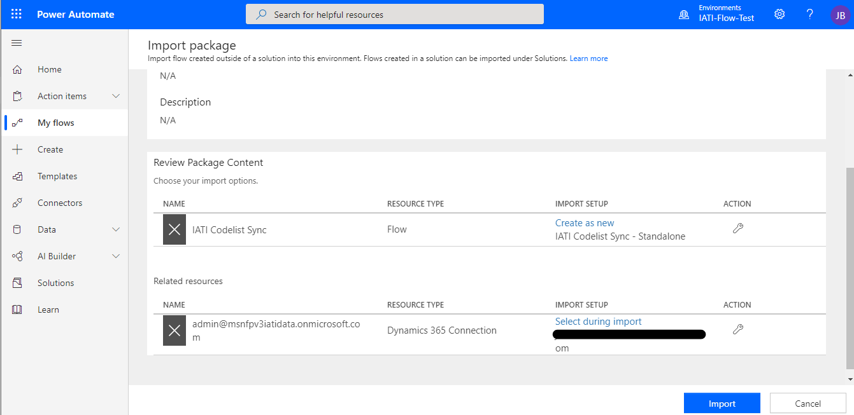

1. After the Flow is imported, click **My Flows**.

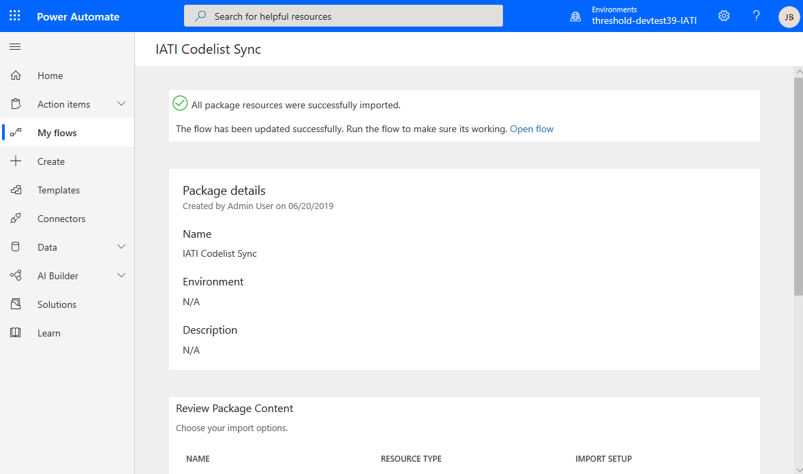

1. Click the **pencil (Edit)** button on the IATI Codelist Sync Flow. A manual page **Refresh** may be necessary if the Flow is not visible on the list.

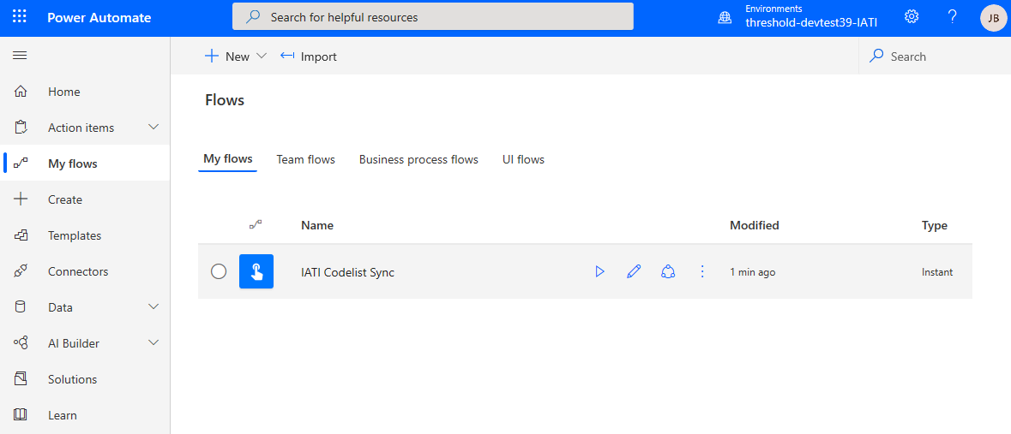

1. Click the **Flow Checker** button.

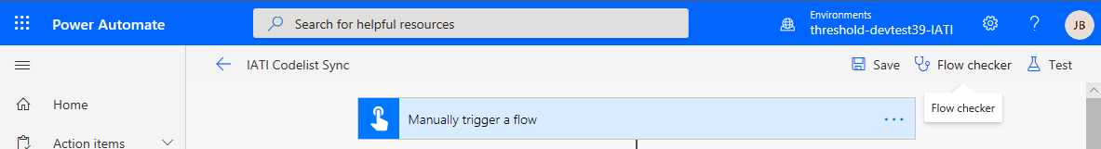

1. Ensure no **Errors** or **Warnings** remain.

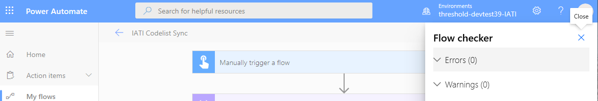

1. Click the **Save** button.

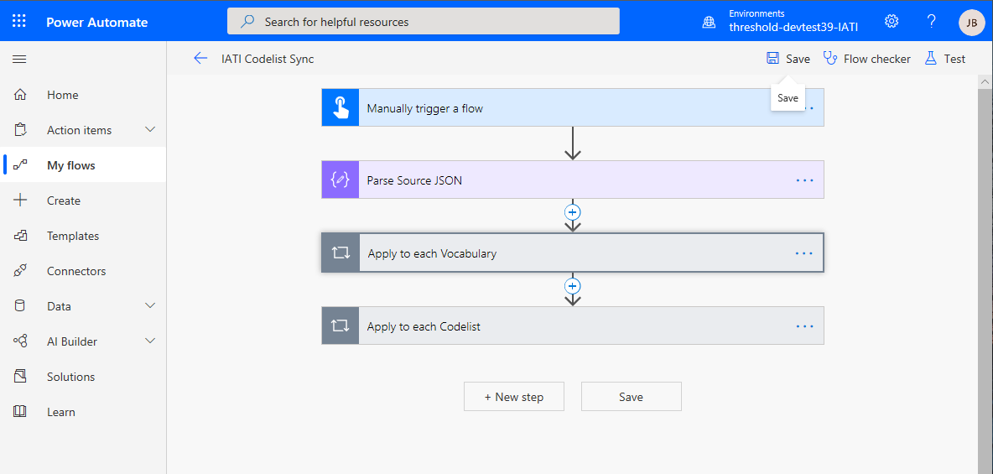

1. Click the **← (Go back to previous page)** button.

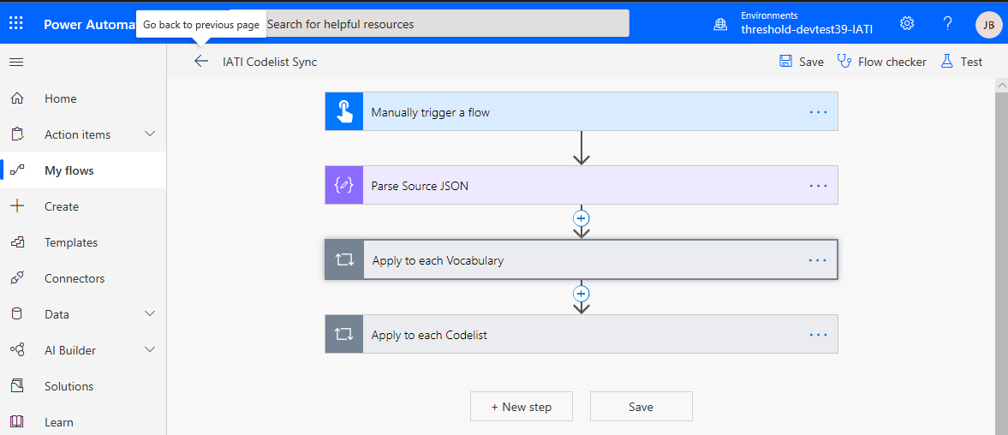

1. Ensure the process is enabled by clicking the **Turn on** button. If the only option available is to **Turn off** the Flow, skip this step.

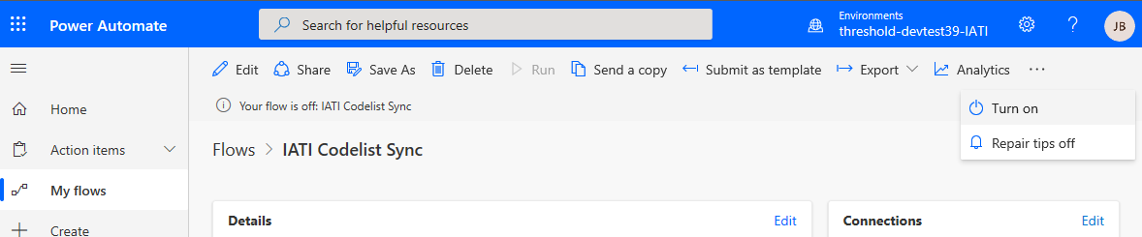

## Execute IATI Codelist Sync Process (standalone)

1. Go to [https://flow.microsoft.com](https://flow.microsoft.com/). Sign in if not already logged in.
2. Click **My** **Flows**.

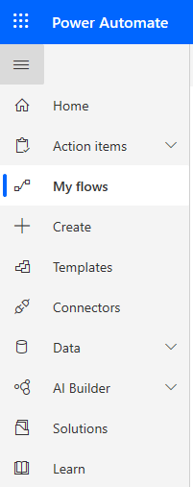

1. Click on the **IATI Codelist Sync** Flow.

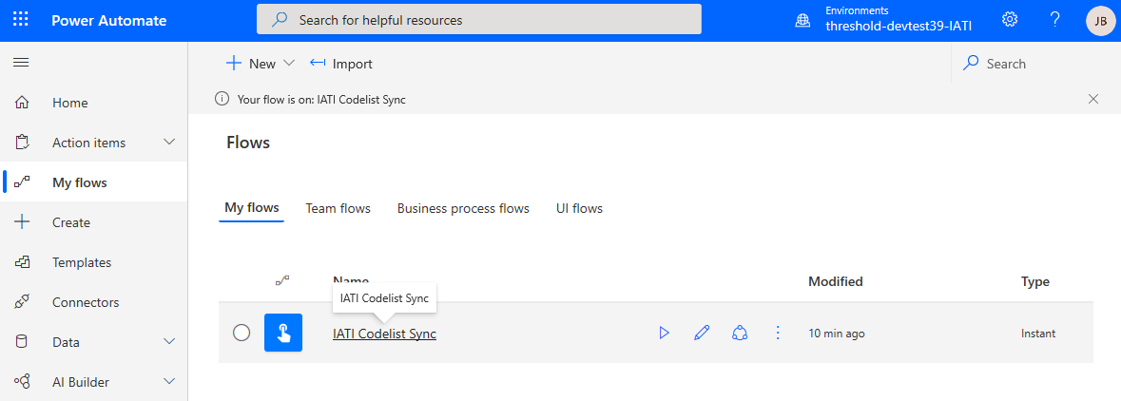

1. Click **Run**.

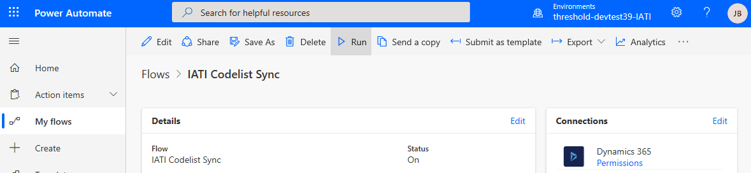

1. Click **Run Flow**



1. Click **Flow Run Page** if you wish to monitor the flow execution.



1. A list will display the flow’s execution history and the status of each run. Allow between **1 and 4 hours** for the process to complete. Time will vary depending on the current load on Dynamics 365.



# Nonprofit and Dynamics 365 for Finance Integration Overview

The Nonprofit Accelerator can connect with Dynamics 365 Finance using Power Apps data Integrator. Data integrator connections will be created for both the Dynamics 365 instance and the Dynamics 365 Finance and Dynamics 365 Supply Chain instance.

Data integrator projects will then be created that will use tasks and mappings to connect the Dynamics 365 data to Dynamics 365 Finance. This will allow a nonprofit to manage their financials in Dynamics 365 Finance.

The Nonprofit Accelerator is available on GitHub at the following address:

<https://github.com/microsoft/Industry-Accelerator-Nonprofit/releases>

## Solution requirements

This solution requires Dynamics 365, the Nonprofit Accelerator version 2.2, Power Apps data integrations and Dynamics 365 Finance. Appropriate credentials also required for the above instances.

## Setting up Dynamics 365 and Dynamics 365 Finance

Setup and configuration should be performed in both Dynamics 365 and Dynamics 365 Finance before setting up and running the integrations. This includes setting up lookup values that will be used as default values passed in the data integrations and making sure lookup values that will be passed as data elements are consistent across both Dynamics 365 and Dynamics 365 Finance to prevent mapping errors. These should be setup in both environments before performing the data integrations so that any execution issues will be minimized. Care should also be taken to ensure that Dynamics 365 fields needed for the data integrations are not set to null where allowed by Dynamics 365.

Here are some lookup values and configurations that should be made per Module:

**Constituent**

* Vendor group and Customer group must be setup in Dynamics 365 Finance
  + One of these values must be used when sending this data element in the integration
* Currency codes must exist in both Dynamics 365 and Dynamics 365 Finance
* Country region Ids must exist in bothDynamics 365 and Dynamics 365 Finance

**Donations**

* Journal name must be setup for General journal in Dynamics 365 Finance
  + This journal name will be sent as a data element in the integration
* Chart of accounts and Financial dimensions should be setup in Dynamics 365 Finance and proper account numbers used in the integration when this type of data is sent in the integrations
* Currency codes must exist in both Dynamics 365 and Dynamics 365 Finance

**Grants & Awards**

* Journal name must be setup for AP Invoice and Vendor payment in Dynamics 365 Finance
  + These journal names will be sent as a data element in the integration
* Chart of accounts and Financial dimensions should be setup in Dynamics 365 Finance and proper account numbers used in the integration when this type of data is sent in the integrations
* Currency codes must exist in both Dynamics 365 and Dynamics 365 Finance

**Program Delivery**

* Project group must be setup in Dynamics 365 Finance
* Project contracts must be setup in Dynamics 365 Finance before running the integration where a specific contract value must be specified
* Budget forecast models for original and remaining must be setup in Dynamics 365 Finance
  + These values will be sent as data elements in the integration

## Power Apps data integrations

Power Apps data integrations will be used to import data from Dynamics 365 to Dynamics 365 Finance.

Visit [admin.powerapps.com](https://make.powerapps.com) and navigate to **Data integration** to view the main data integration page. This is where the data integration projects will be setup to allow for the import process to be run that will transfer data from Dynamics 365 to Dynamics 365 Finance.

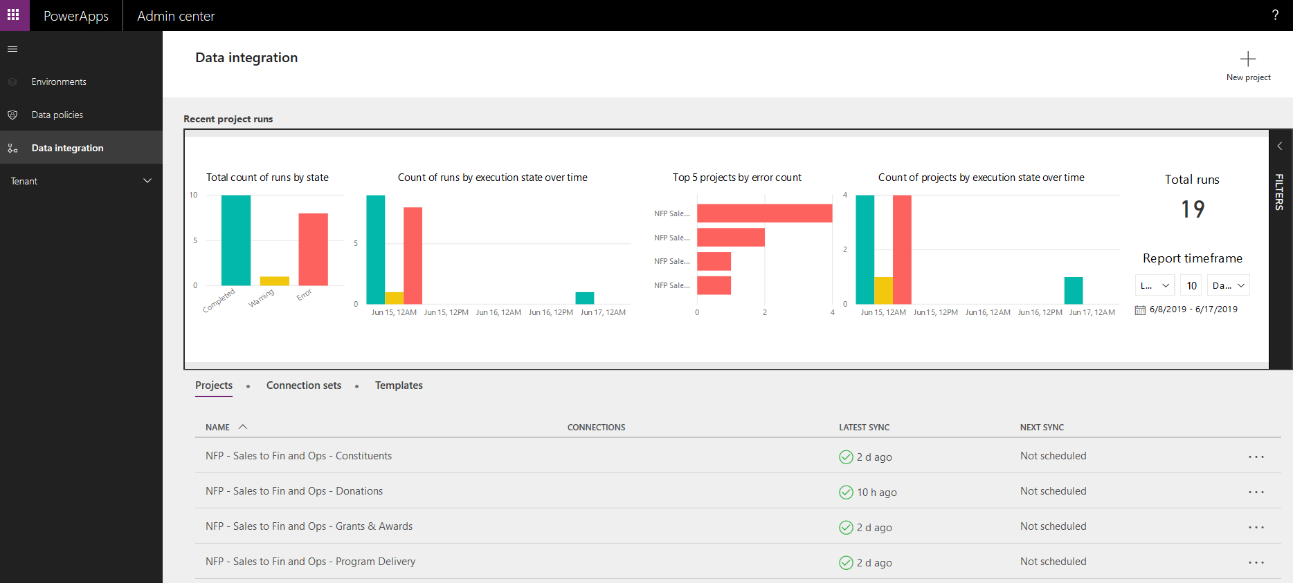

## Creating Power Apps connectors

The Power Apps connectors are used by the data integrator to connect to both Dynamics 365 and Dynamics 365 Finance. Credentials for each are required.

Visit [make.powerapps.com](https://make.powerapps.com) and navigate to **Data** > **Connections**. Create new connectors for Dynamics 365 and Dynamics 365 Finance by clicking **+ New Connection** at the top of the page.

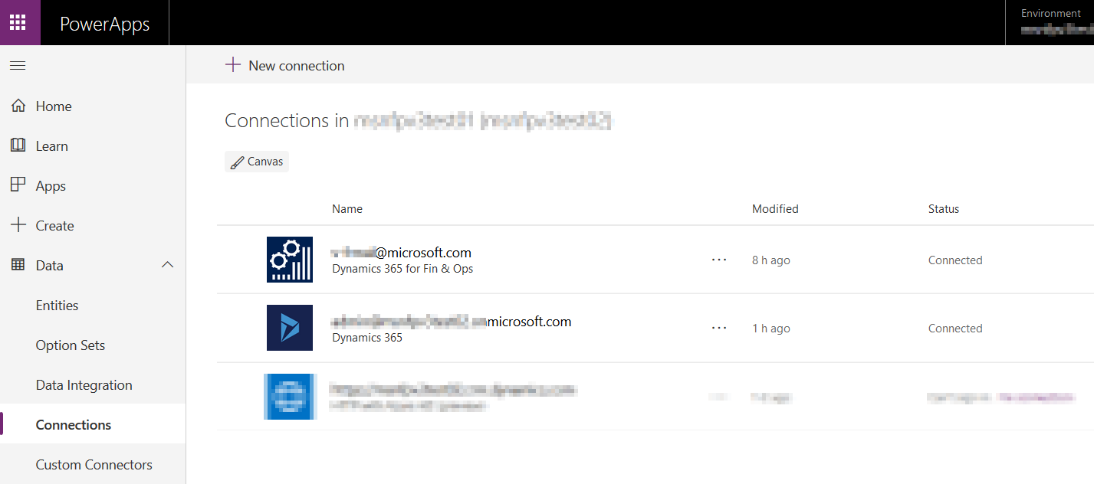

First choose the Dynamics 365 connector from list of connectors. You can use the icon to help identify it since the list is long. Click **Create** when the following dialog appears:

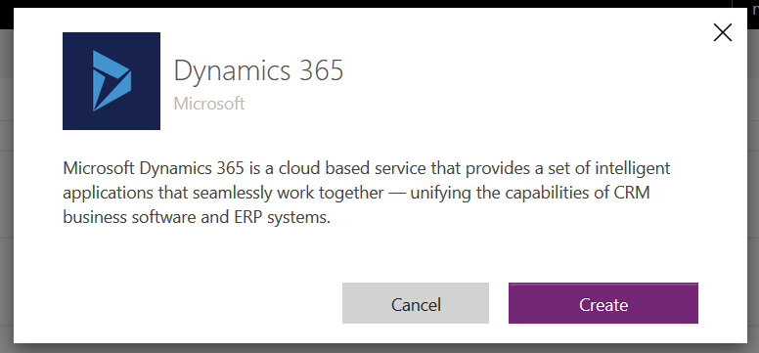

You will be asked to provide credentials for the connector. You can also choose to save the credentials.

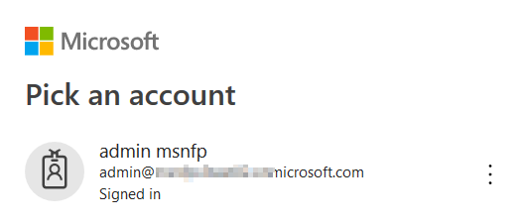

Next create the connection for Dynamics 365 Finance, again entering credentials after you click **Create**:

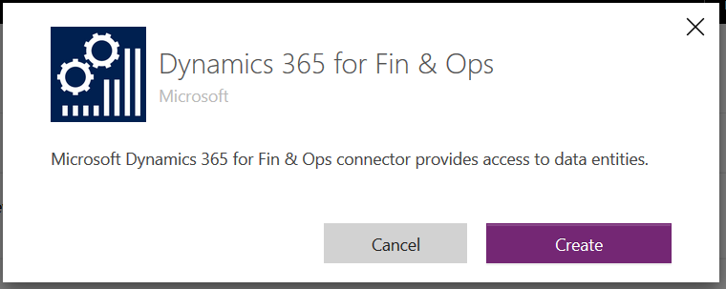

## Creating Power Apps data integration connection sets

Go to [admin.powerapps.com](https://admin.powerapps.com) and click **Data integration** on the menu on the left. Create a new connection set by clicking **+ New Connector Set** in the upper right:

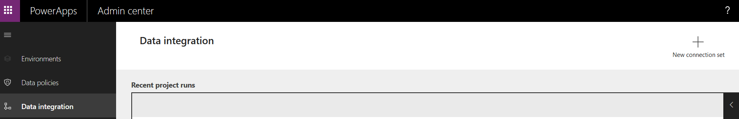

Enter a name for the connection set. Since the name field only accepts alphanumeric characters a good naming convention like the following can be used. If multiple connection sets exist, then they will sort properly and be easier to identify.

<Dynamics365_Instance>0< Dynamics365_Company>2<Dynamics_365_Finance _Instance>0< Dynamics_365_Finance _Company>

Choose the connection (from the connectors that were setup in the previous section) and environment from the dropdowns. The first connection/environment should be the Dynamics 365 connection and environment. The second connection/environment should be the Dynamics 365 Finance connection and environment.

Then enter the organization/company information for each and click **Create** to finish creating the connection set.

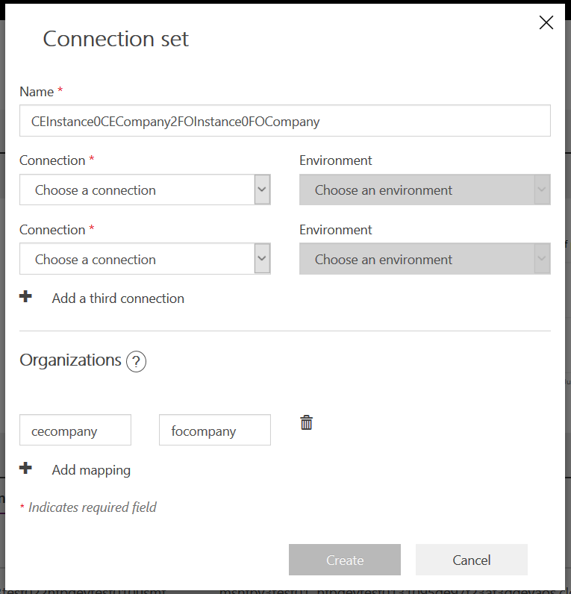

## Creating Power Apps data integration projects

When creating new projects, you can select from existing versioned templates to create your project. This document describes integrations that move data from Dynamics 365 to Dynamics 365 Finance. Instructions for importing or manually creating Projects from Templates are in the next section. Templates are provided for the Nonprofit Accelerator in GitHub that are based on the Dynamics 365 Sales to Dynamics 365 Finance template type.

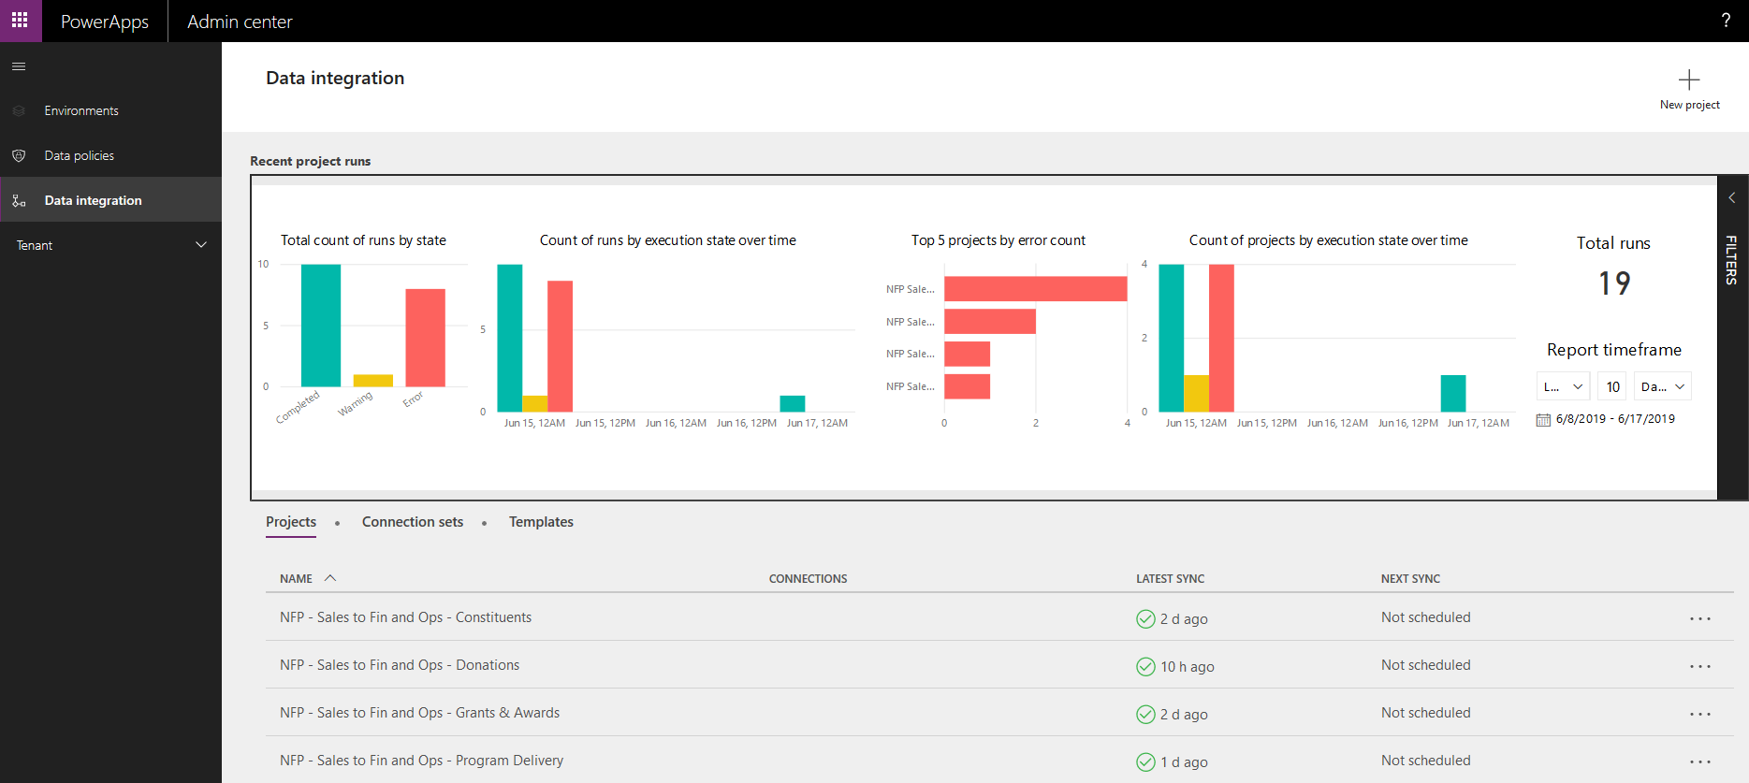

You choose a name to give the project. Since there are no groups for templates they will sort alphabetically, so it is good idea to use some sort of prefix if you are going to have multiple projects. 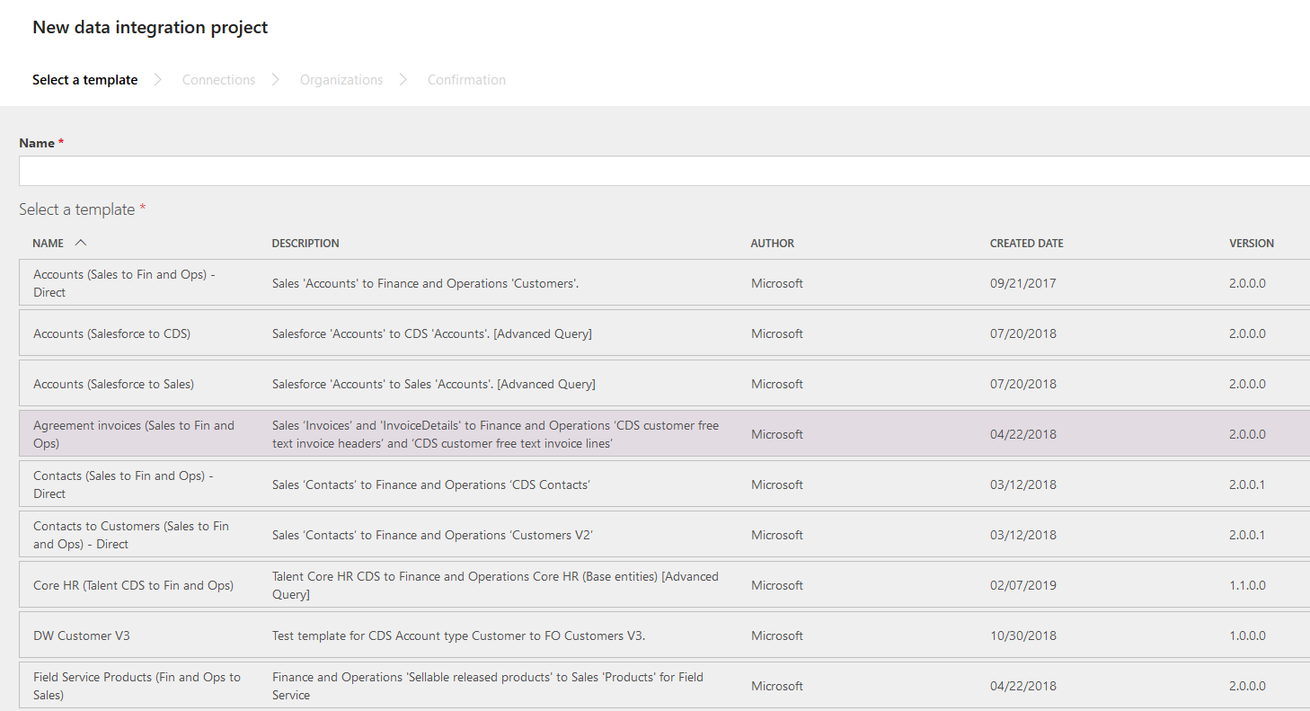

Next you choose a Template name, such as Sales to Fin and Ops and click **Next**.

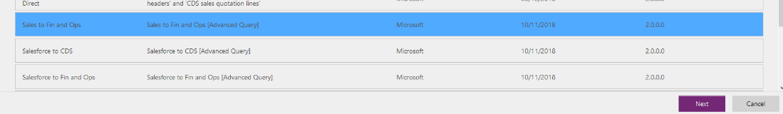

Then choose a connection set from list of connection sets you have created in the Power Apps data integration connection sets section above and click **Next**.

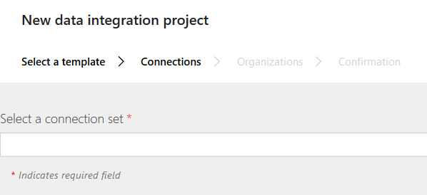

Choose an Organization and click **Next**:

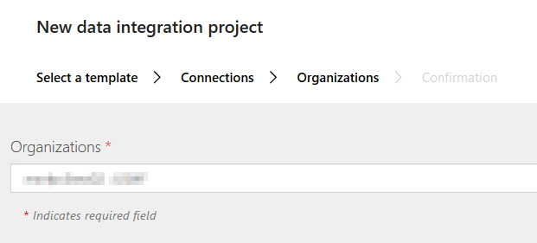

Then finally click **Create** to create your project.

## Importing Power Apps data integration templates

If data integration template Import functionality is available then the templates provided on GitHub can be used to import into your Power Apps data integrator, creating the projects for you. If the method of creating via import is not available, you can use the mappings in the Power Apps data integration mappings section below along with the template files provided in JSON format to manually create your own data integration projects.

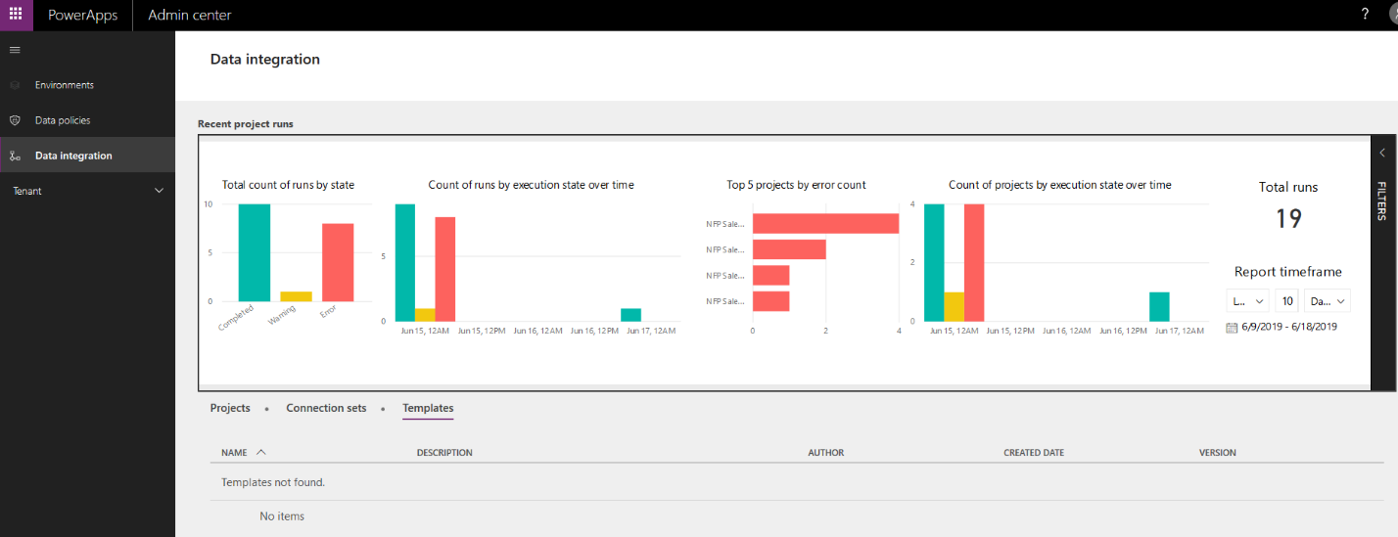

## Saving Power Apps projects as templates

Projects can be saved as Templates so that they can be used when creating other projects. Click on the **…** and choose **Save as template** in order to save the template.

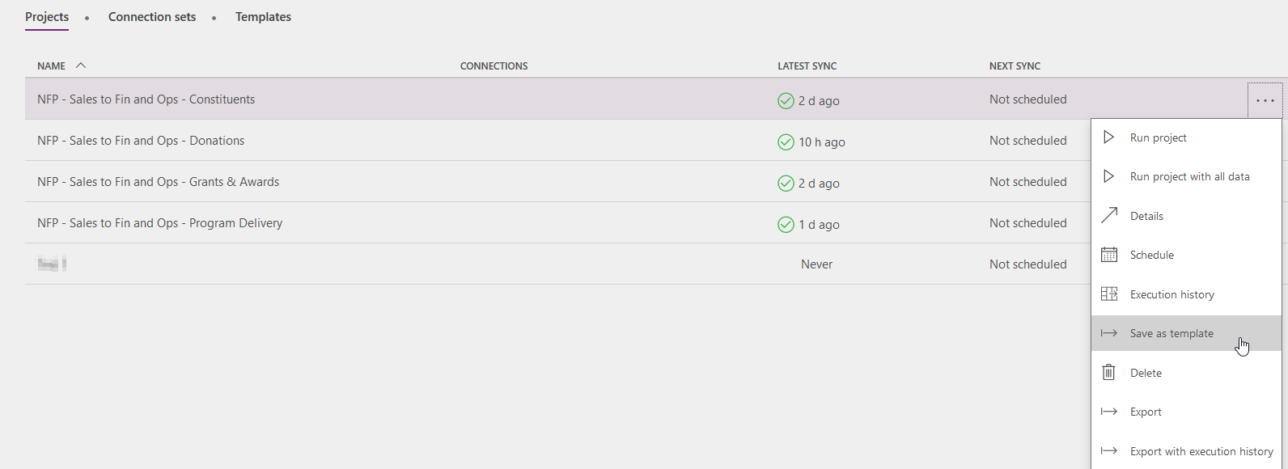

Enter a name and optional description for the template and then click **Save**. Then others will be able to choose this template from the list when creating new projects.

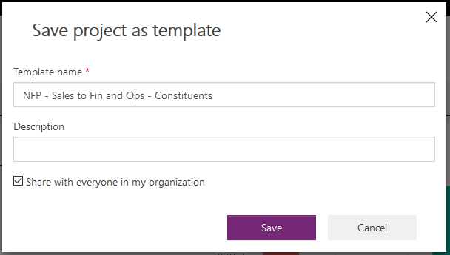

## Exporting Power Apps data integration templates

To export a project click on the … for that project row and choose **Export**.

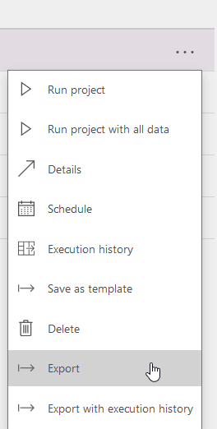

A file dialog will appear, and you can save your export file. The exported file is a zip file that includes the exported project in JSON format within.

## Creating Power Apps data integration tasks

This section details the data integration tasks for each Nonprofit Accelerator module in this release. You may wish to modify these tasks and their mappings based on the needs of your business. There are 4 modules included: Constituents, Donations, Grants & Awards and Program Delivery.

**Constituents** **project tasks**

|  |  |  |  |
| --- | --- | --- | --- |
| **Task** | **Source (Dynamics 365) table** | **Destination (Dynamics 365 Finance) table** | **Dynamics 365 Finance navigation** |
| Accounts to Customers | accounts | Vendors V2 | **Accounts payable** > **Vendors** > **All vendors** |
| Accounts to Vendors | contacts | Vendors V2 | **Accounts payable** > **Vendors** > **All vendors** |
| Contacts to Customers | contacts | Customers V3 | **Accounts receivable** > **Customers** > **All customers** |
| Accounts to Customers | accounts | Customers V3 | **Accounts receivable** > **Customers** > **All customers** |

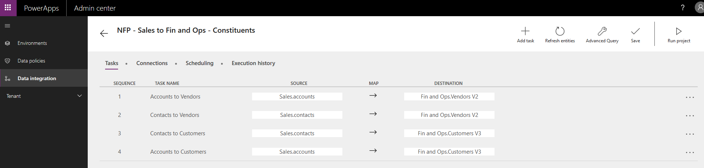

**Donations** **project tasks**

|  |  |  |  |
| --- | --- | --- | --- |
| **Task** | **Source (Dynamics 365) table** | **Destination (Dynamics 365 Finance) table** | **Dynamics 365 Finance navigation** |
| Donor Commitment to General Journal | msnfp_donorcommitments | General journal | **General ledger** > **Journal entries** > **General journals** |
| Transaction to Customer Payment Journal Header | msnfp_transactions | Customer payment journal header | **Accounts receivable** > **Payments** > **Customer payment journal** |
| Transaction to Customer Payment Journal Line | msnfp_transactions | Customer payment journal line | **Accounts receivable** > **Payments** > **Customer payment journal** > **Lines** |
| Designated Credit to General Journal | msnfp_designatedcredits | General journal | **General ledger** > **Journal entries** > **General journals** |

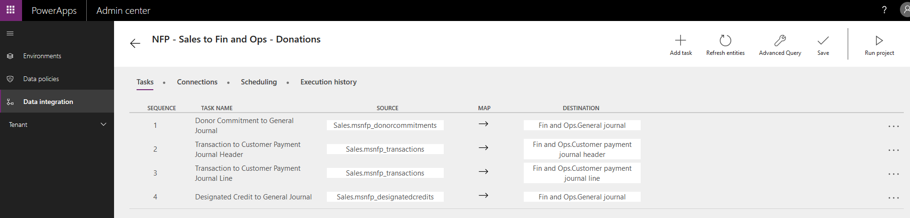

**Grants & Awards project tasks**

|  |  |  |  |
| --- | --- | --- | --- |
| **Task** | **Source (Dynamics 365) table** | **Destination (Dynamics 365 Finance) table** | **Dynamics 365 Finance navigation** |
| Disbursement Distributions to Vendor Invoice Journal Header | msnfp_disbursementdistributions | Vendor invoice journal header | **Accounts payable** > **Invoices** > **Invoice journal** |
| Disbursement Distributions to Vendor Invoice Journal Line | msnfp_disbursementdistributions | Vendor invoice journal line | **Accounts payable** > **Invoices** > **Invoice journal** > **Lines** |
| Disbursements to Vendor Payment Journal Header | msnfp_disbursements | Vendor payment journal header | **Accounts payable** > **Payments** > **Vendor payment journal** |
| Disbursements to Vendor Payment Journal Line | msnfp_disbursements | Vendor payment journal line | **Accounts payable** > **Payments** > **Vendor payment journal** > **Lines** |

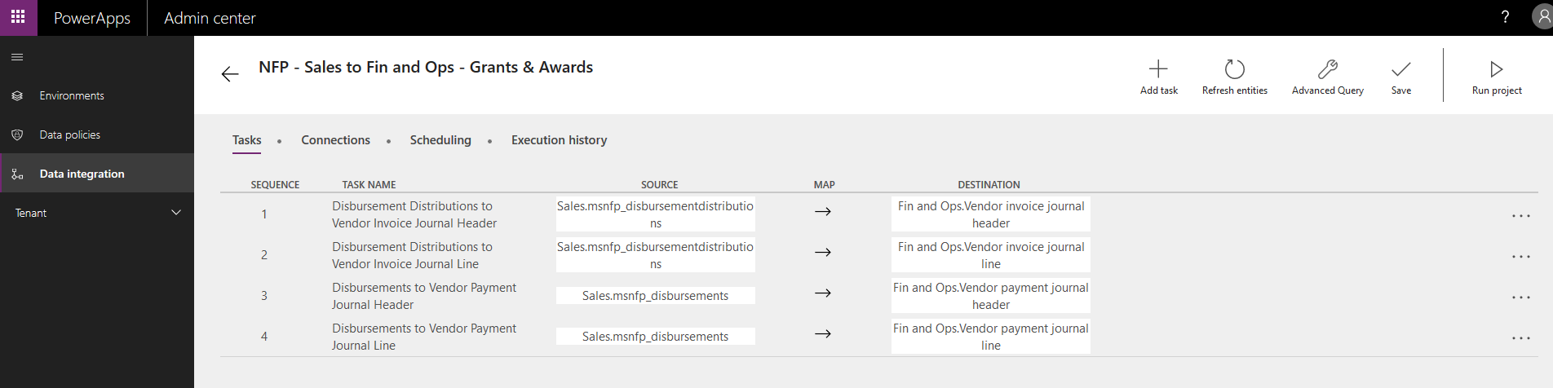

**Program Delivery** **project tasks**

|  |  |  |  |
| --- | --- | --- | --- |
| **Task** | **Source (Dynamics 365) table** | **Destination (Dynamics 365 Finance) table** | **Dynamics 365 Finance navigation** |
| Delivery Framework to Projects | msnfp_deliveryframeworks | Projects | **Project management and accounting** > **Projects** > **All projects** |
| Budgets to Project Budgets | msnfp_budgets | Project budget | **Project management and accounting** > **Projects** > **All projects** > **Project** > **Project Budget** |

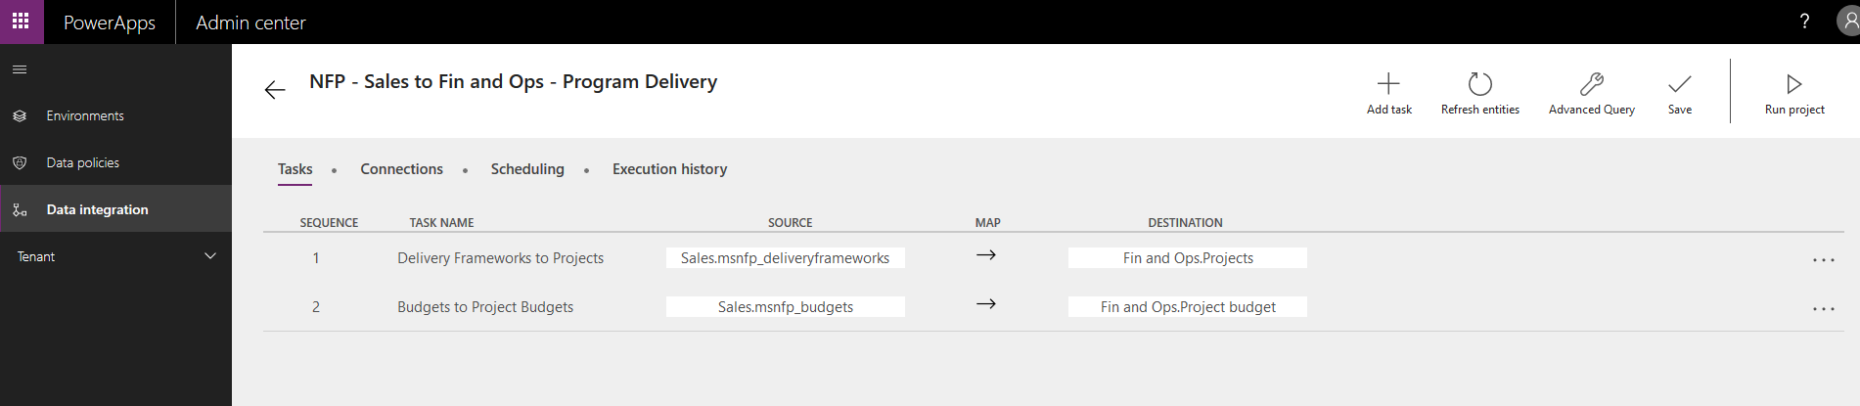

## Mapping Power Apps data integration fields

To get to the data mapping user will need to click on one of the project tasks to view the mappings as shown below. This page will map the Dynamics 365data table elements to the Dynamics 365 Finance data table elements and allow for data to be transformed if necessary.

Use the mapping spreadsheets provided with the Nonprofit Accelerator in GitHub at the following address to help you create your data mappings for the project tasks:

<https://github.com/microsoft/Industry-Accelerator-Nonprofit/releases>

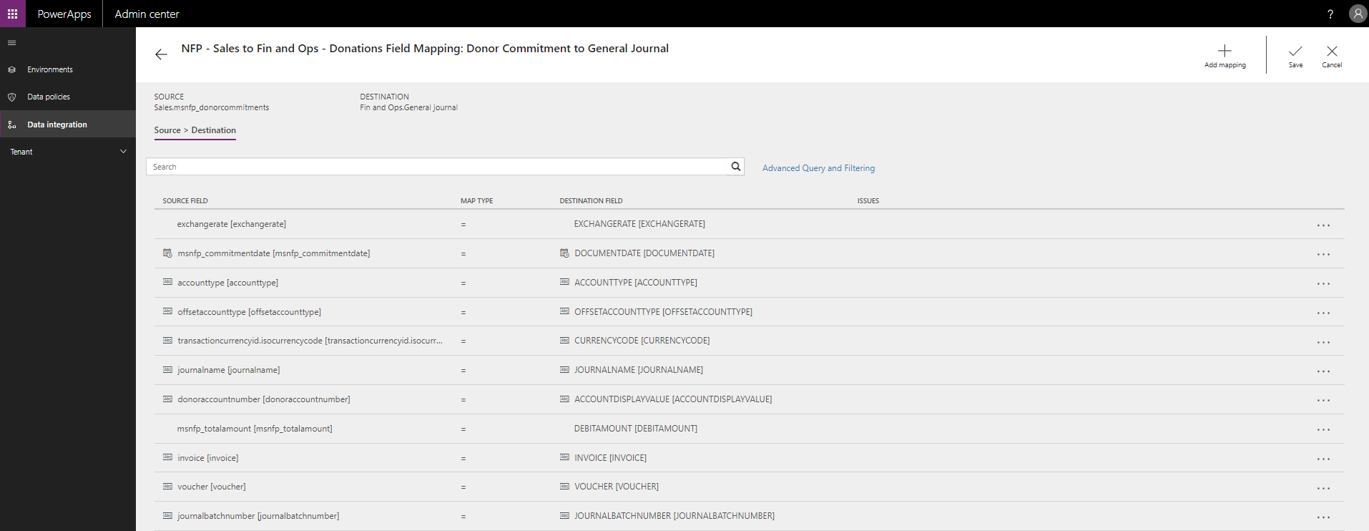

## Using Power Apps data integration advanced query

Advanced query and filtering allows the user to combine, transform, and filter data. Possible data sources include SQL Server, OData, Excel, Text/CSV, JSON files and many others.

To use the advanced query and filtering, click **Advanced Query and Filtering** on any field mapping page:

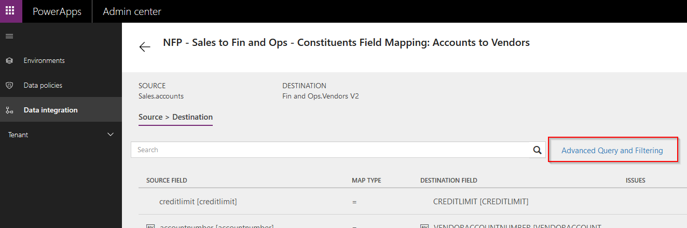

The top ribbon has the components for simple data management. The advanced editor can be used to make other modifications besides the presented on the ribbon. To get into the editor, right click one of the tables and click **Advanced editor**.

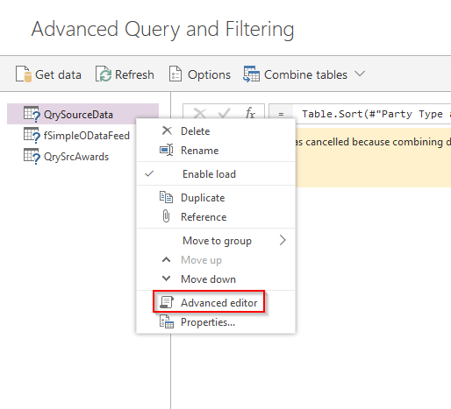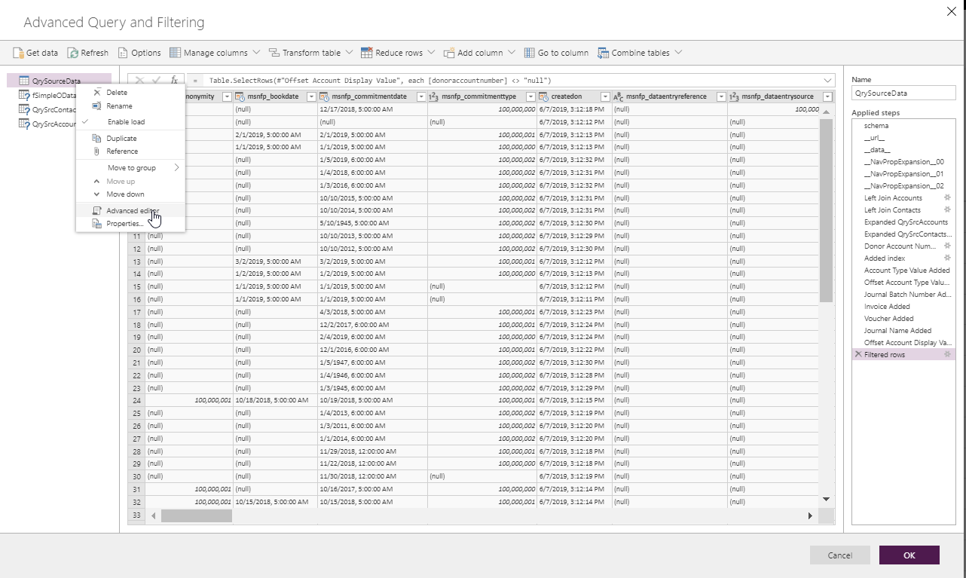

From there Power Query M can be used to transform data. For more information visit the Power Query M reference at the following address:

[Power Query M Reference](https://docs.microsoft.com/en-us/powerquery-m/power-query-m-reference)

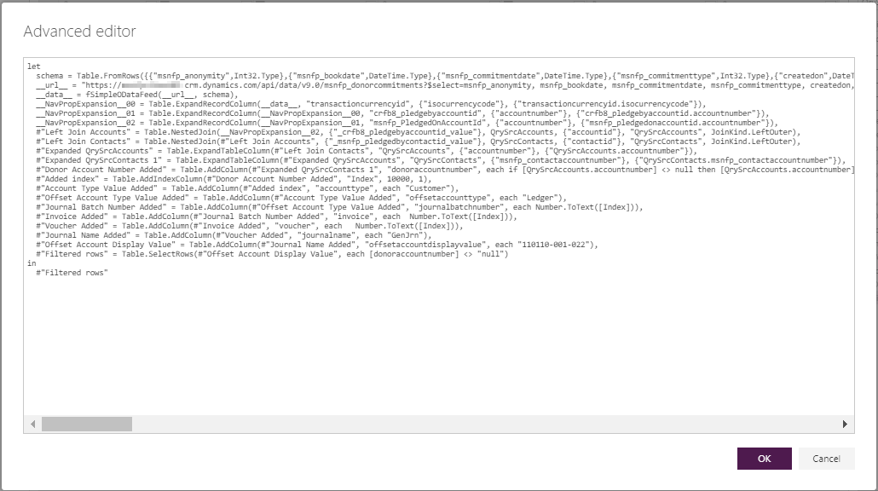

## Executing Power Apps data integrations

Run projects by clicking **Run project** in the upper right-hand corner of the page. An execution history can be viewed by clicking **Execution history**. This will show the status, run date & time, and counts of upserts (inserts or updates) and errors.

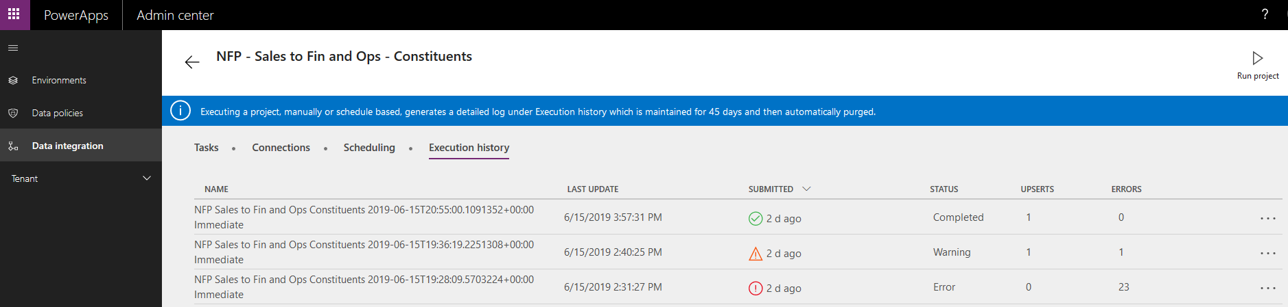

## Scheduling Power Apps data integrations

Projects can also be scheduled to run on a recurring basis by clicking **Scheduling**.

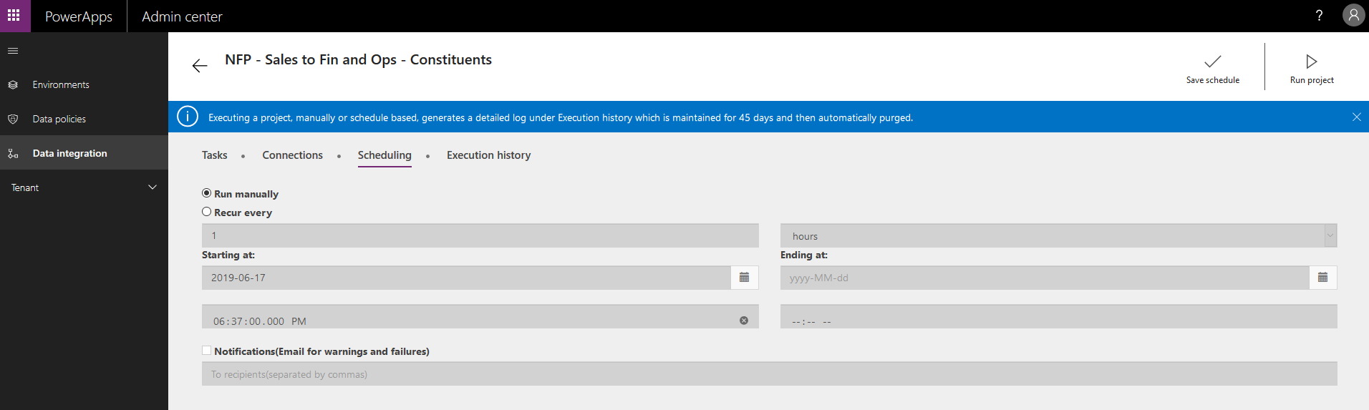

## Troubleshooting Power Apps data integrations

**Execution history** shows each execution run. Each line is clickable and can be drilled into to see the execution details.

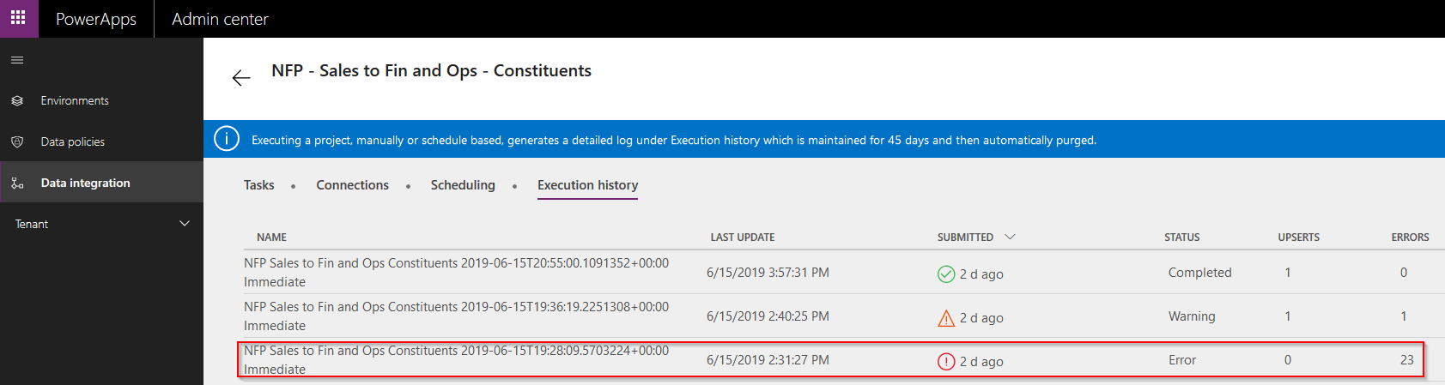

Each task line for the execution details can also be drilled into if it is not in completed status:

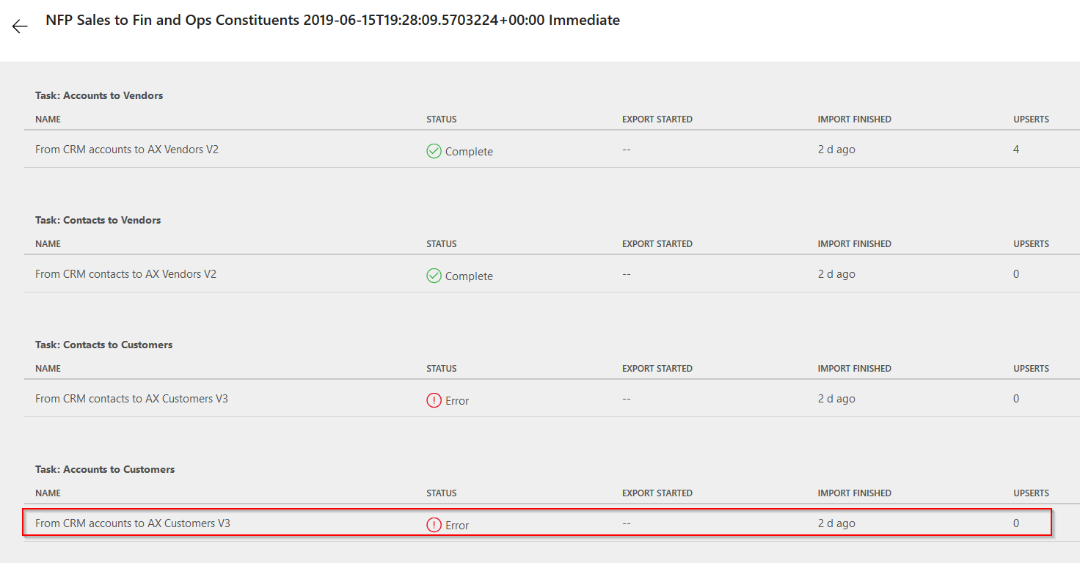

Additional detailed error information can be found for the error conditions:

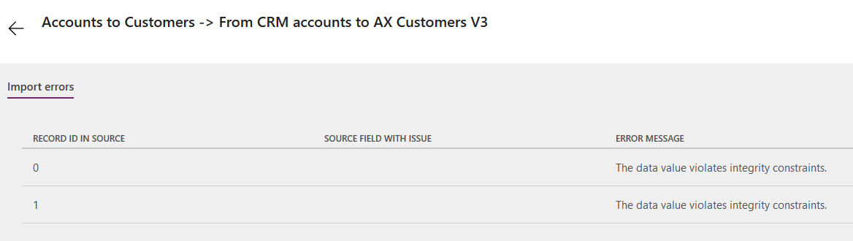

If the execution run is in a warning state, the row can also be drilled into to view warning details:

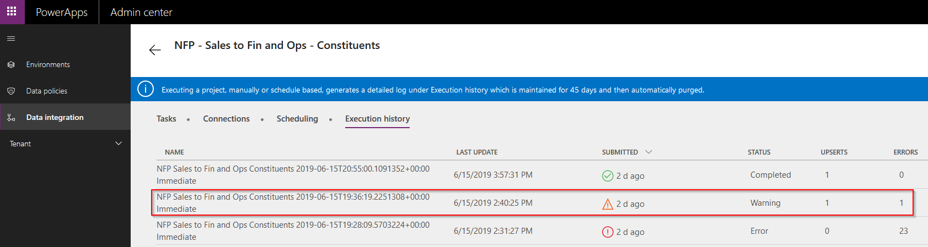

In this case a state catalog value in Dynamics 365 (“New York”) does not match the expected state catalog value (“NY”) in Dynamics 365 Finance:

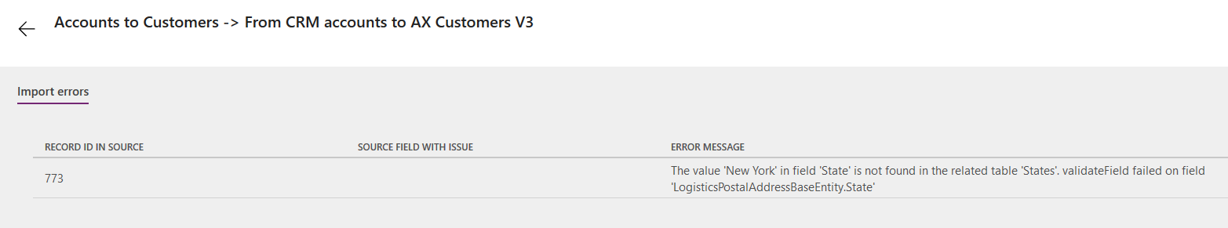

For execution runs that complete successfully the task details can be seen along with upsert counts:

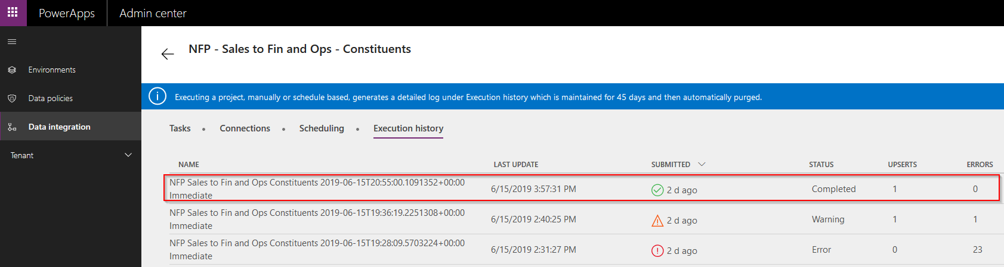

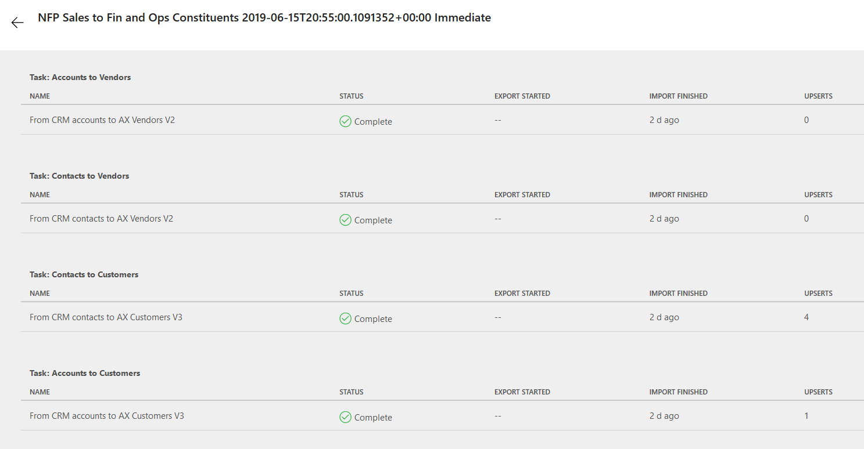

## Using Dynamics 365 Finance data management

The data integrations use data entities in Dynamics 365 Finance. Raw data is transferred to staging tables. Validations are done and the upserts are performed with this data. Users can view this staging data and manage the entity mappings and properties in Dynamics 365 Finance.

Go to **Workspaces** > **Data management**:

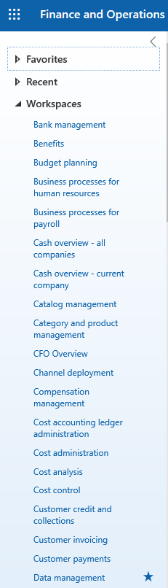

Data management is broken up into three sections: Import / Export, Data projects, and Job history.

Import / Export allows you to configure and view data entities.

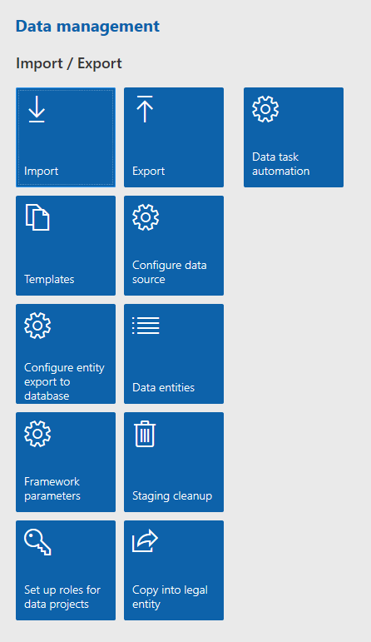

Data entities opens a form that shows details on each data entity and allows users to configure the mappings and validations.

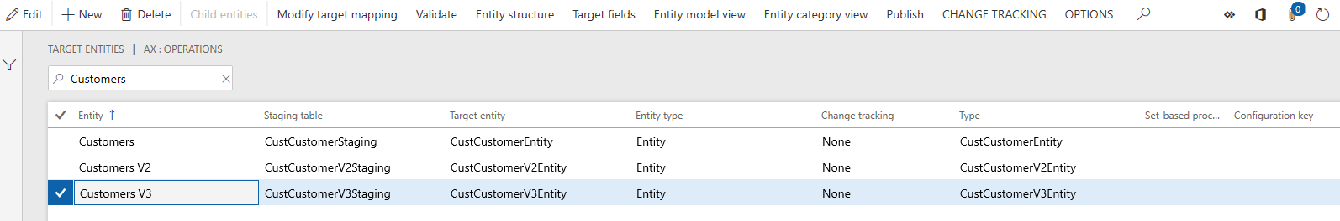

The general journal entity may require unchecking the Set-based processing column and the business validations and logic if there are issues importing.

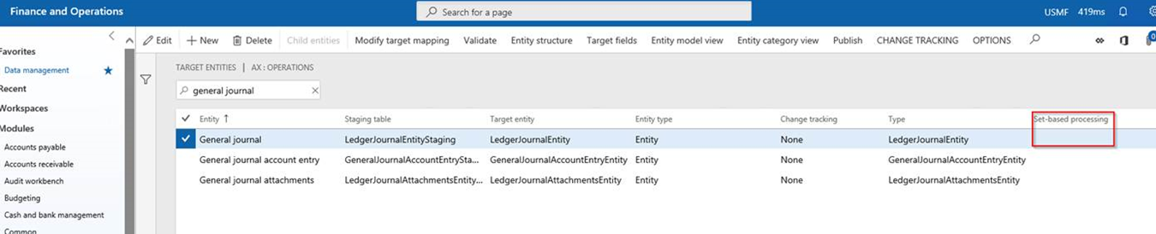

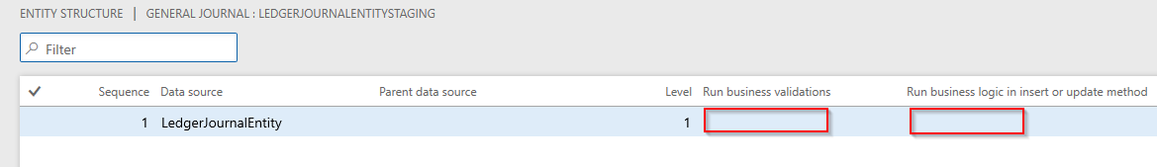

Click **Entity Structure** at top to configure whether the business validations or business logic is run when inserting or updating. This should only be changed if there is a valid reason to bypass any Dynamics 365 Finance business validations or logic.

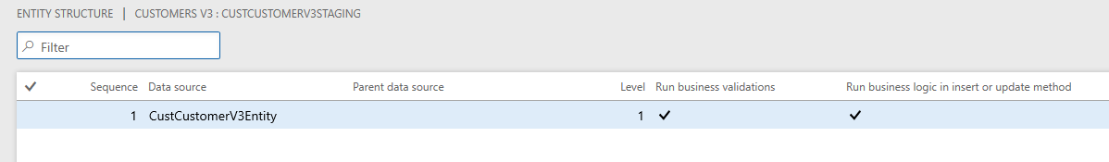

Data projects allows you to manage and run data projects.

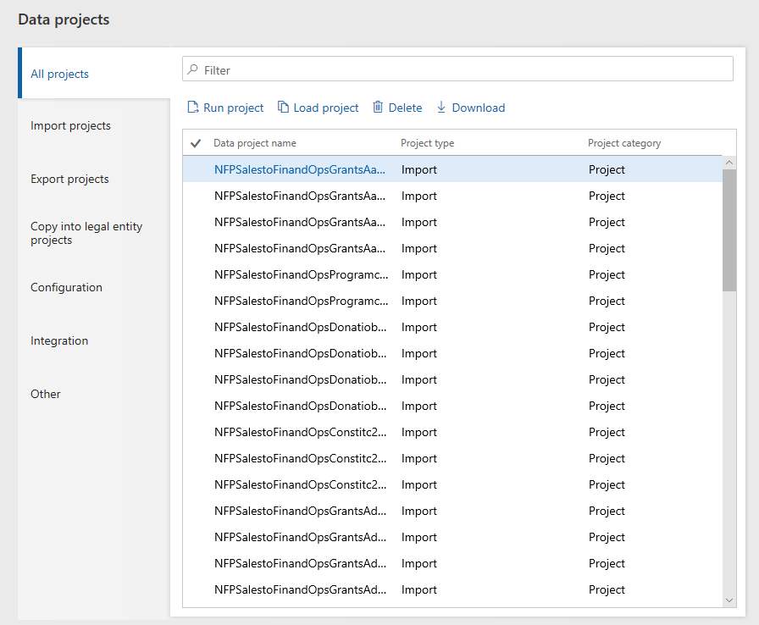

Job history allows you to view previous executions. Click **Execution details** to view project details.

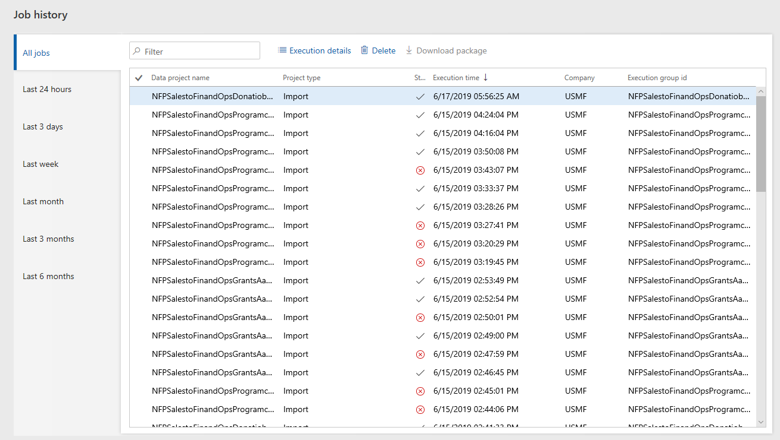

Click **View staging data** to view details for that execution.

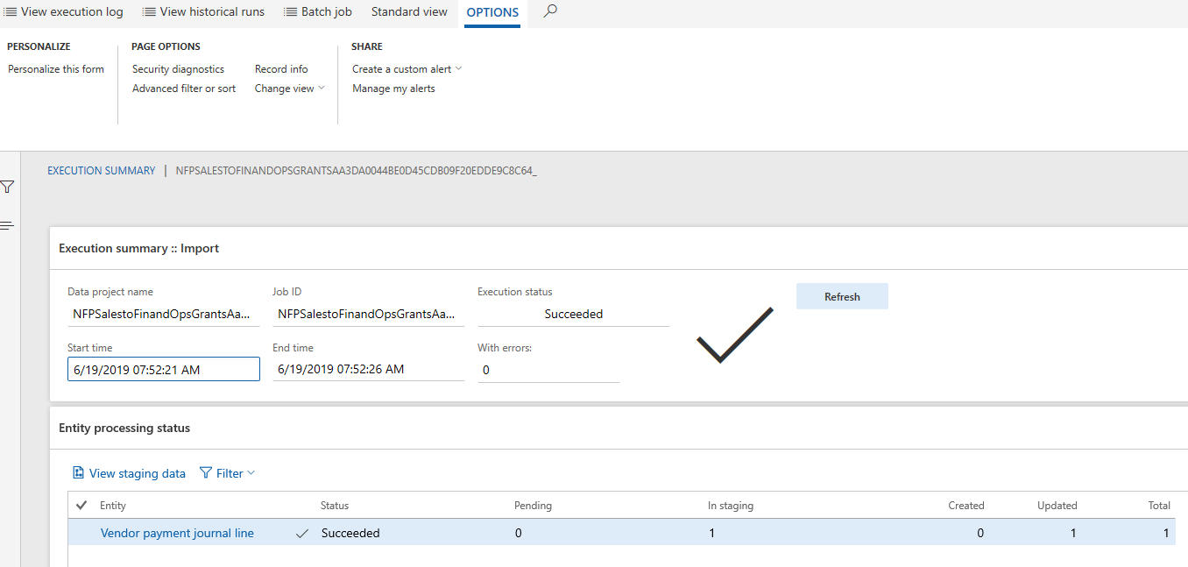

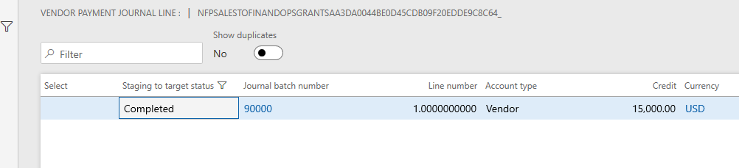

If errors occurred, you can view the detailed error message below the staging data.

## Data Mappings

These are the mappings between the nonprofit accelerator and Dynamics 365 for finance.

### Constituent

Constituent Data Mapping

### Donations

Donations Data Mapping

### Program Delivery

Program Delivery Data Mapping

### Grants & Awards

Grants & Awards Data Mapping

## References

The following is a list of NFP Dynamics 365 to Dynamics 365 Finance integration references mentioned in this document:

1. Nonprofit Accelerator

<https://github.com/microsoft/Industry-Accelerator-Nonprofit/releases>

1. AppSource

[appsource.microsoft.com/en-us/marketplace/apps?embedHost=dynamics-365&embedCorrelationId=56bdba52-8af8-44de-98e6-a4471df24dc8](https://appsource.microsoft.com/en-us/marketplace/apps?embedHost=dynamics-365&embedCorrelationId=56bdba52-8af8-44de-98e6-a4471df24dc8)

1. Power Apps Admin (for data integrations)

[admin.powerapps.com](https://admin.powerapps.com)

1. Power Apps Make (for connectors)

[make.powerapps.com](https://make.powerapps.com)

1. Power Query M Reference

[docs.microsoft.com/en-us/powerquery-m/power-query-m-reference](https://docs.microsoft.com/en-us/powerquery-m/power-query-m-reference)